Results - SR - AC vs PC

Jesse Wood

Sept 12, 2018

Setup

library("unmarked")

## Loading required package: reshape

## Loading required package: lattice

## Loading required package: parallel

## Loading required package: Rcpp

setwd("C:/Users/woodj/Documents/GRAD SCHOOL - CLEMSON/Project-Specific/R work/USDA-songbirds/USDA-songbirds")

# Evaluate Audio Counts (AC) vs Point Counts (PC)

Visit 1

#File read-in  
# as of 6/22, this one-visit breakdown has had unknowns REMOVED now (in both AC + PC)  
methodSR1 <-read.csv("17_1by1_ACPC_SR.csv") #SR by 1 visit each - Site Type SR  
summary(methodSR1)

## SiteName Type SR Sdate   
## Abercrombie_0B_E_AB: 2 AC:29 Min. : 8.00 Min. : 0.00   
## Abercrombie_1B_2 : 2 PC:29 1st Qu.:12.00 1st Qu.: 2.25   
## Blease_3B_6 : 2 Median :14.00 Median : 8.00   
## Blease_3B_9 : 2 Mean :14.24 Mean :12.83   
## Bryson_2B_9 : 2 3rd Qu.:16.00 3rd Qu.:22.75   
## Burnett_1B_5 : 2 Max. :21.00 Max. :50.00   
## (Other) :46   
## Stime Pdate Pmin Peffort Year   
## Min. :353.0 Min. :43181 Min. :12.00 Min. :1.000 A:58   
## 1st Qu.:404.0 1st Qu.:43185 1st Qu.:18.00 1st Qu.:2.000   
## Median :435.0 Median :43189 Median :24.00 Median :2.000   
## Mean :447.7 Mean :43189 Mean :25.48 Mean :3.172   
## 3rd Qu.:496.2 3rd Qu.:43193 3rd Qu.:30.00 3rd Qu.:3.000   
## Max. :589.0 Max. :43196 Max. :65.00 Max. :8.000   
## NA's :29 NA's :29 NA's :29

str(methodSR1)

## 'data.frame': 58 obs. of 9 variables:  
## $ SiteName: Factor w/ 29 levels "Abercrombie_0B_E_AB",..: 3 4 5 7 8 12 13 14 15 16 ...  
## $ Type : Factor w/ 2 levels "AC","PC": 1 1 1 1 1 1 1 1 1 1 ...  
## $ SR : int 15 14 11 10 12 16 13 17 14 11 ...  
## $ Sdate : int 3 16 31 33 23 24 30 27 10 22 ...  
## $ Stime : int 570 403 497 380 503 382 479 481 580 409 ...  
## $ Pdate : int 43181 43181 43186 43195 43196 43182 43188 43188 43188 43188 ...  
## $ Pmin : int 26 23 17 20 32 31 18 20 25 18 ...  
## $ Peffort : int 3 2 1 2 3 3 2 2 4 3 ...  
## $ Year : Factor w/ 1 level "A": 1 1 1 1 1 1 1 1 1 1 ...

#plot(methodSR1$SR ~ methodSR1$Type) #same as below  
plot(SR ~ Type, data=methodSR1)

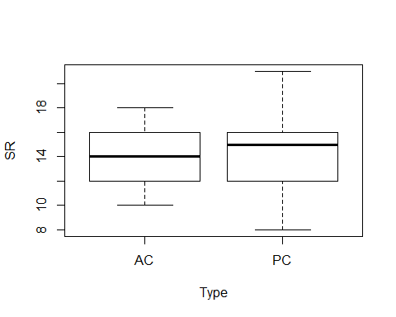

plot(SR ~ Sdate, data=methodSR1)

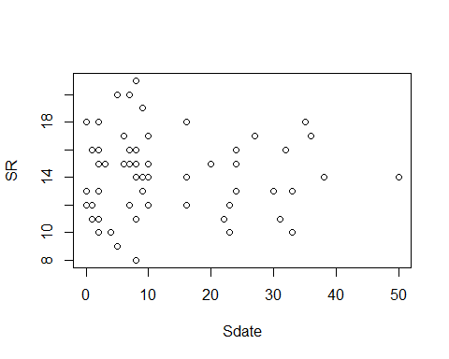

plot(SR ~ Stime, data=methodSR1)

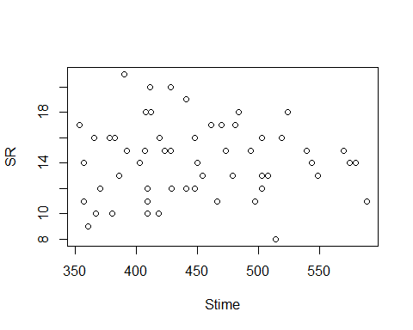

plot(SR ~ Pdate, data=methodSR1)

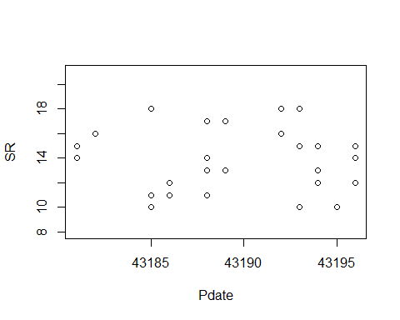

plot(SR ~ Pmin, data=methodSR1)

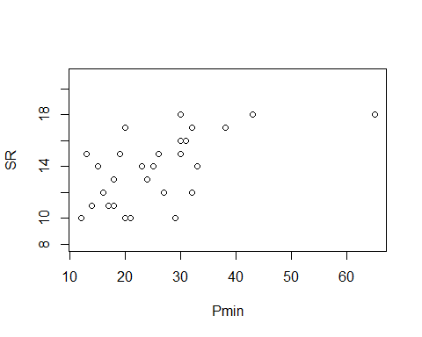

plot(SR ~ Peffort, data=methodSR1)

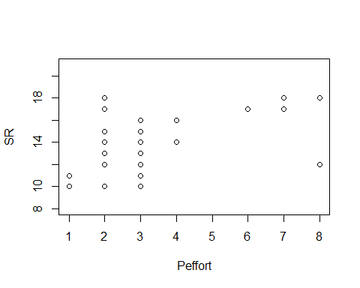

evaluation1<-lm(SR ~ Type, methodSR1) #non-significant  
summary(evaluation1)

##   
## Call:  
## lm(formula = SR ~ Type, data = methodSR1)  
##   
## Residuals:  
## Min 1Q Median 3Q Max   
## -6.6552 -2.4483 0.1724 1.3448 6.3448   
##   
## Coefficients:  
## Estimate Std. Error t value Pr(>|t|)   
## (Intercept) 13.8276 0.5418 25.52 <2e-16 ***  
## TypePC 0.8276 0.7662 1.08 0.285   
## ---  
## Signif. codes: 0 '***' 0.001 '**' 0.01 '*' 0.05 '.' 0.1 ' ' 1  
##   
## Residual standard error: 2.918 on 56 degrees of freedom  
## Multiple R-squared: 0.02041, Adjusted R-squared: 0.002915   
## F-statistic: 1.167 on 1 and 56 DF, p-value: 0.2847

confint(evaluation1, level=0.95)

## 2.5 % 97.5 %  
## (Intercept) 12.7422657 14.912907  
## TypePC -0.7072887 2.362461

anova(evaluation1)

## Analysis of Variance Table  
##   
## Response: SR  
## Df Sum Sq Mean Sq F value Pr(>F)  
## Type 1 9.93 9.9310 1.1667 0.2847  
## Residuals 56 476.69 8.5123

plot(evaluation1)

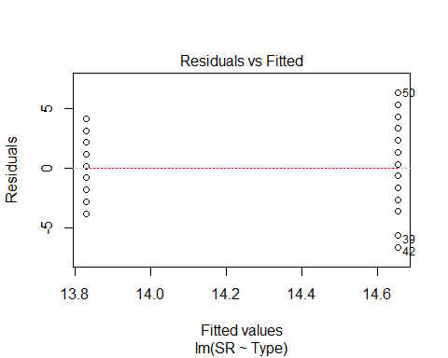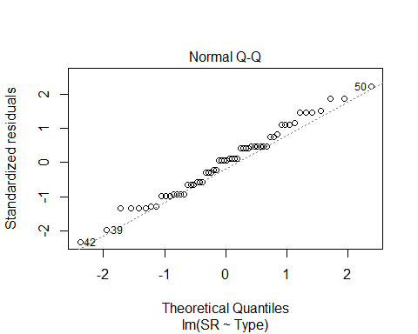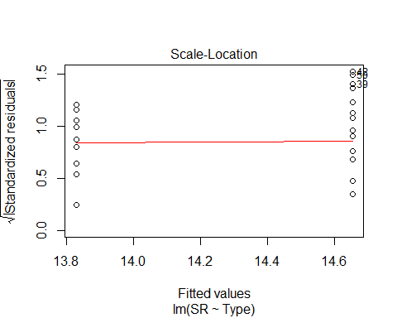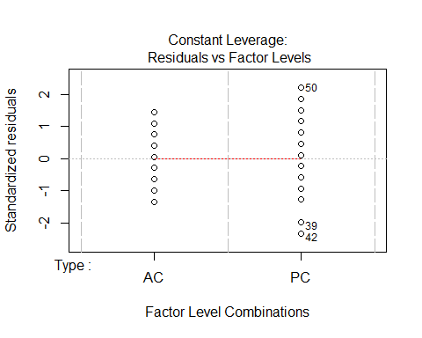

evaluation2<-lm(SR ~ Sdate, methodSR1) #non-significant  
summary(evaluation2)

##   
## Call:  
## lm(formula = SR ~ Sdate, data = methodSR1)  
##   
## Residuals:  
## Min 1Q Median 3Q Max   
## -6.2677 -2.2690 -0.0717 1.7310 6.7323   
##   
## Coefficients:  
## Estimate Std. Error t value Pr(>|t|)   
## (Intercept) 14.311221 0.562822 25.428 <2e-16 ***  
## Sdate -0.005445 0.031860 -0.171 0.865   
## ---  
## Signif. codes: 0 '***' 0.001 '**' 0.01 '*' 0.05 '.' 0.1 ' ' 1  
##   
## Residual standard error: 2.947 on 56 degrees of freedom  
## Multiple R-squared: 0.0005212, Adjusted R-squared: -0.01733   
## F-statistic: 0.0292 on 1 and 56 DF, p-value: 0.8649

confint(evaluation2, level=0.95)

## 2.5 % 97.5 %  
## (Intercept) 13.18375378 15.43868911  
## Sdate -0.06926792 0.05837855

anova(evaluation2)

## Analysis of Variance Table  
##   
## Response: SR  
## Df Sum Sq Mean Sq F value Pr(>F)  
## Sdate 1 0.25 0.2536 0.0292 0.8649  
## Residuals 56 486.37 8.6851

plot(evaluation2)

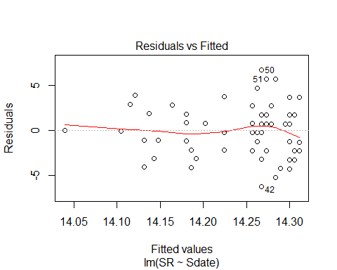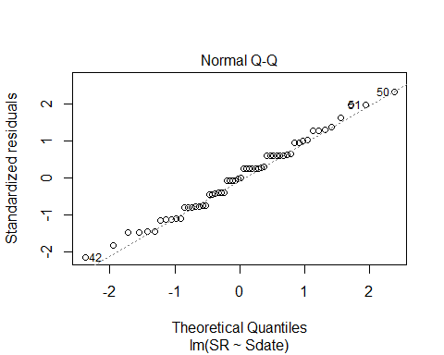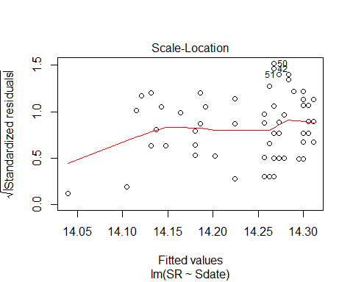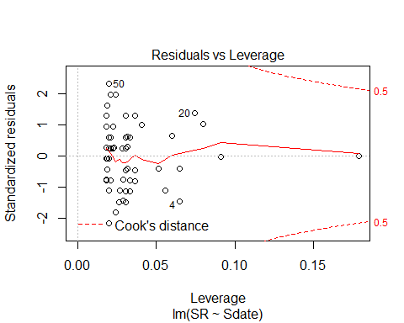

Sdate2<-methodSR1$Sdate^2  
Sdate2

## [1] 9 256 961 1089 529 576 900 729 100 484 400 1089 529 2500  
## [15] 16 576 100 576 1444 1225 100 100 1024 1296 4 256 64 4  
## [29] 256 4 4 1 49 49 1 81 64 64 25 25 49 64  
## [43] 64 4 4 81 4 4 36 64 49 81 1 0 0 36  
## [57] 0 0

evaluation2B<-lm(SR ~ Sdate2, methodSR1) #non-significant  
summary(evaluation2B)

##   
## Call:  
## lm(formula = SR ~ Sdate2, data = methodSR1)  
##   
## Residuals:  
## Min 1Q Median 3Q Max   
## -6.2788 -2.2792 0.0091 1.7206 6.7212   
##   
## Coefficients:  
## Estimate Std. Error t value Pr(>|t|)   
## (Intercept) 14.2884727 0.4593742 31.10 <2e-16 ***  
## Sdate2 -0.0001509 0.0007934 -0.19 0.85   
## ---  
## Signif. codes: 0 '***' 0.001 '**' 0.01 '*' 0.05 '.' 0.1 ' ' 1  
##   
## Residual standard error: 2.947 on 56 degrees of freedom  
## Multiple R-squared: 0.0006456, Adjusted R-squared: -0.0172   
## F-statistic: 0.03618 on 1 and 56 DF, p-value: 0.8498

confint(evaluation2B, level=0.95)

## 2.5 % 97.5 %  
## (Intercept) 13.368235525 15.208709827  
## Sdate2 -0.001740229 0.001438415

anova(evaluation2B)

## Analysis of Variance Table  
##   
## Response: SR  
## Df Sum Sq Mean Sq F value Pr(>F)  
## Sdate2 1 0.31 0.3142 0.0362 0.8498  
## Residuals 56 486.31 8.6840

plot(evaluation2B)

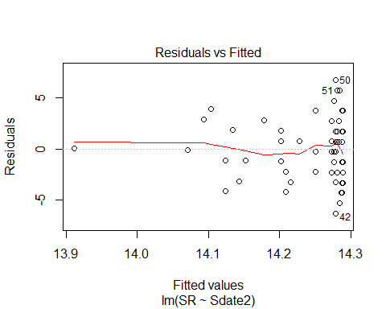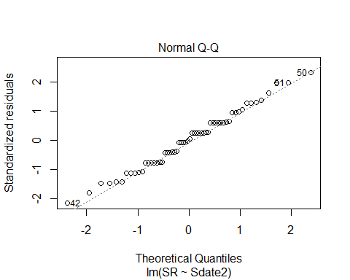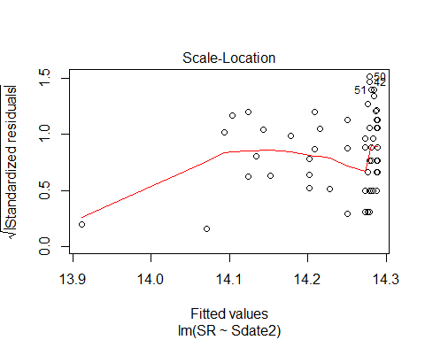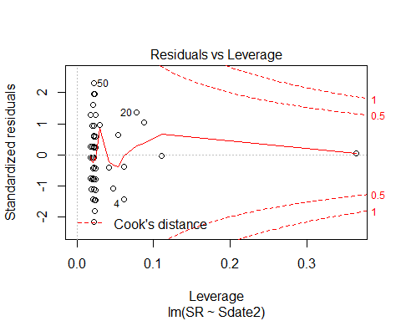

evaluation3<-lm(SR ~ Stime, methodSR1) #non-significant  
summary(evaluation3)

##   
## Call:  
## lm(formula = SR ~ Stime, data = methodSR1)  
##   
## Residuals:  
## Min 1Q Median 3Q Max   
## -6.1714 -2.2580 -0.1044 1.7512 6.6977   
##   
## Coefficients:  
## Estimate Std. Error t value Pr(>|t|)   
## (Intercept) 14.714004 2.769534 5.313 1.93e-06 ***  
## Stime -0.001056 0.006125 -0.172 0.864   
## ---  
## Signif. codes: 0 '***' 0.001 '**' 0.01 '*' 0.05 '.' 0.1 ' ' 1  
##   
## Residual standard error: 2.947 on 56 degrees of freedom  
## Multiple R-squared: 0.0005301, Adjusted R-squared: -0.01732   
## F-statistic: 0.0297 on 1 and 56 DF, p-value: 0.8638

confint(evaluation3, level=0.95)

## 2.5 % 97.5 %  
## (Intercept) 9.1659604 20.26204685  
## Stime -0.0133252 0.01121406

anova(evaluation3)

## Analysis of Variance Table  
##   
## Response: SR  
## Df Sum Sq Mean Sq F value Pr(>F)  
## Stime 1 0.26 0.258 0.0297 0.8638  
## Residuals 56 486.36 8.685

plot(evaluation3)

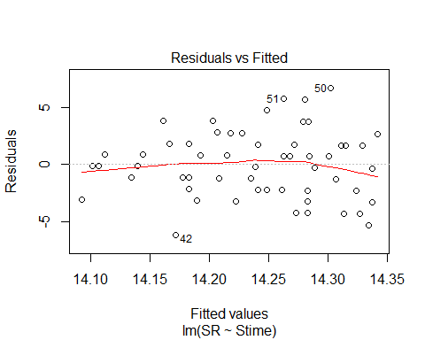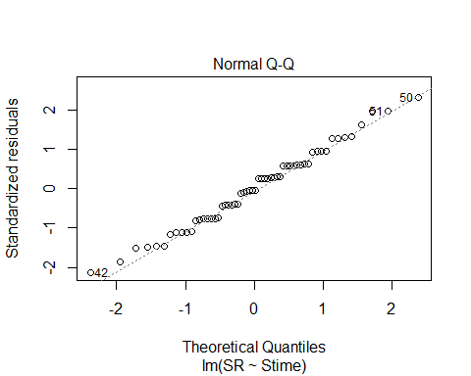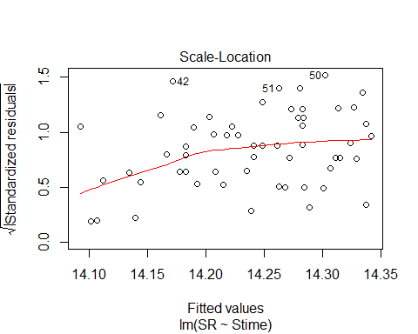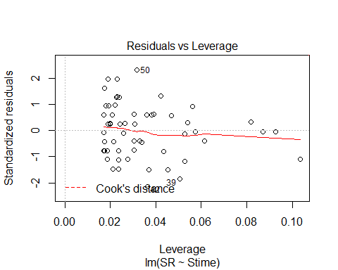

Stime2<-methodSR1$Stime^2  
evaluation3B<-lm(SR ~ Stime2, methodSR1) #non-significant  
summary(evaluation3B)

##   
## Call:  
## lm(formula = SR ~ Stime2, data = methodSR1)  
##   
## Residuals:  
## Min 1Q Median 3Q Max   
## -6.1399 -2.2716 -0.0222 1.7416 6.6697   
##   
## Coefficients:  
## Estimate Std. Error t value Pr(>|t|)   
## (Intercept) 1.459e+01 1.404e+00 10.393 1.11e-14 ***  
## Stime2 -1.699e-06 6.599e-06 -0.257 0.798   
## ---  
## Signif. codes: 0 '***' 0.001 '**' 0.01 '*' 0.05 '.' 0.1 ' ' 1  
##   
## Residual standard error: 2.946 on 56 degrees of freedom  
## Multiple R-squared: 0.001182, Adjusted R-squared: -0.01665   
## F-statistic: 0.06624 on 1 and 56 DF, p-value: 0.7978

confint(evaluation3B, level=0.95)

## 2.5 % 97.5 %  
## (Intercept) 1.177670e+01 1.740065e+01  
## Stime2 -1.491892e-05 1.152180e-05

anova(evaluation3B)

## Analysis of Variance Table  
##   
## Response: SR  
## Df Sum Sq Mean Sq F value Pr(>F)  
## Stime2 1 0.57 0.5750 0.0662 0.7978  
## Residuals 56 486.05 8.6794

plot(evaluation3B)

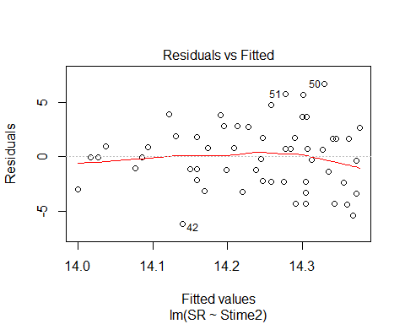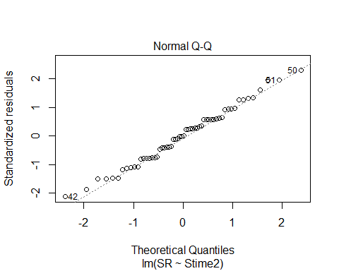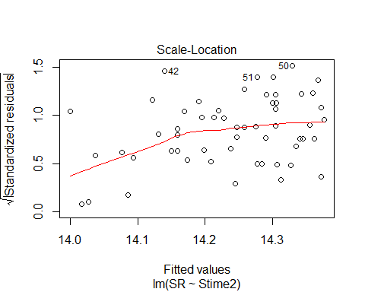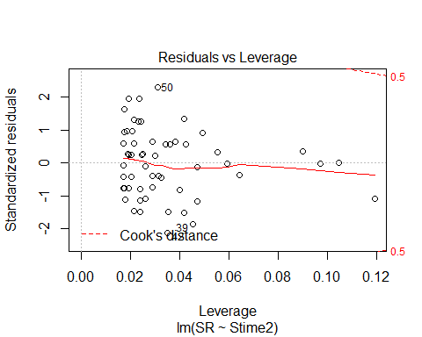

evaluation4<-lm(SR ~ Pdate, methodSR1) #non-significant  
summary(evaluation4)

##   
## Call:  
## lm(formula = SR ~ Pdate, data = methodSR1)  
##   
## Residuals:  
## Min 1Q Median 3Q Max   
## -3.8595 -1.8649 0.1784 2.1568 4.1946   
##   
## Coefficients:  
## Estimate Std. Error t value Pr(>|t|)  
## (Intercept) -2.196e+02 4.516e+03 -0.049 0.962  
## Pdate 5.405e-03 1.046e-01 0.052 0.959  
##   
## Residual standard error: 2.667 on 27 degrees of freedom  
## (29 observations deleted due to missingness)  
## Multiple R-squared: 9.895e-05, Adjusted R-squared: -0.03693   
## F-statistic: 0.002672 on 1 and 27 DF, p-value: 0.9592

confint(evaluation4, level=0.95)

## 2.5 % 97.5 %  
## (Intercept) -9486.472261 9047.2182069  
## Pdate -0.209159 0.2199698

anova(evaluation4)

## Analysis of Variance Table  
##   
## Response: SR  
## Df Sum Sq Mean Sq F value Pr(>F)  
## Pdate 1 0.019 0.0190 0.0027 0.9592  
## Residuals 27 192.119 7.1155

plot(evaluation4)

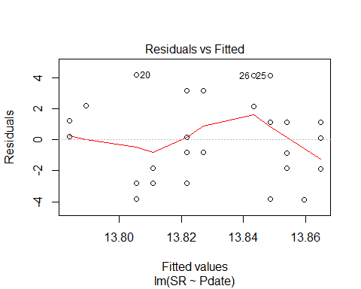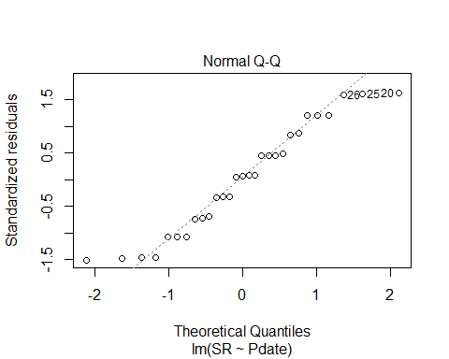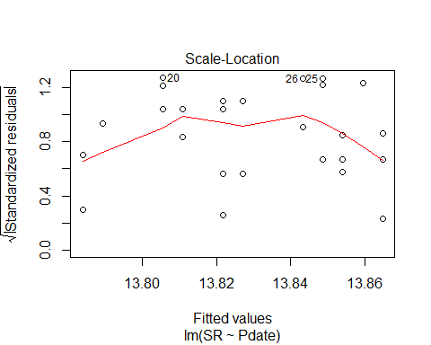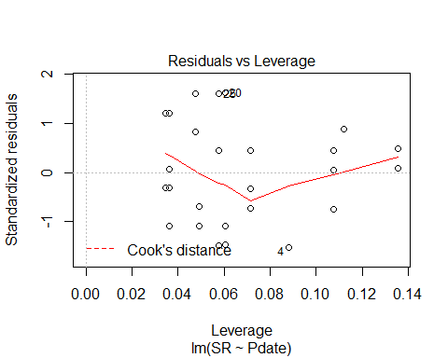

Pdate2<-(methodSR1$Pdate)^2  
evaluation4B<-lm(SR ~ Pdate2, methodSR1) #non-significant  
summary(evaluation4B)

##   
## Call:  
## lm(formula = SR ~ Pdate2, data = methodSR1)  
##   
## Residuals:  
## Min 1Q Median 3Q Max   
## -3.8595 -1.8649 0.1784 2.1568 4.1946   
##   
## Coefficients:  
## Estimate Std. Error t value Pr(>|t|)  
## (Intercept) -1.029e+02 2.258e+03 -0.046 0.964  
## Pdate2 6.257e-08 1.211e-06 0.052 0.959  
##   
## Residual standard error: 2.667 on 27 degrees of freedom  
## (29 observations deleted due to missingness)  
## Multiple R-squared: 9.891e-05, Adjusted R-squared: -0.03693   
## F-statistic: 0.002671 on 1 and 27 DF, p-value: 0.9592

confint(evaluation4B, level=0.95)

## 2.5 % 97.5 %  
## (Intercept) -4.736346e+03 4.530587e+03  
## Pdate2 -2.421467e-06 2.546602e-06

anova(evaluation4B)

## Analysis of Variance Table  
##   
## Response: SR  
## Df Sum Sq Mean Sq F value Pr(>F)  
## Pdate2 1 0.019 0.0190 0.0027 0.9592  
## Residuals 27 192.119 7.1155

plot(evaluation4B)

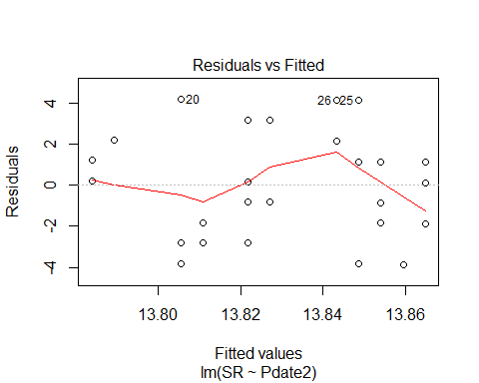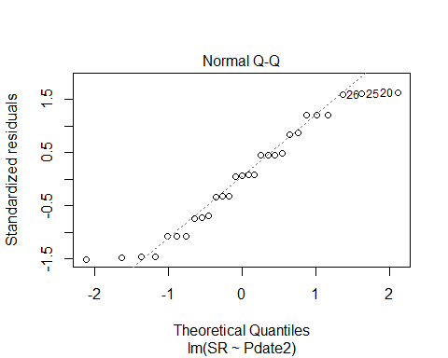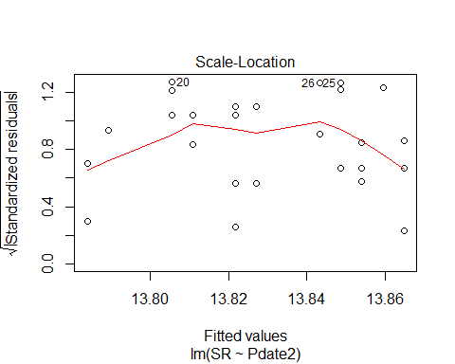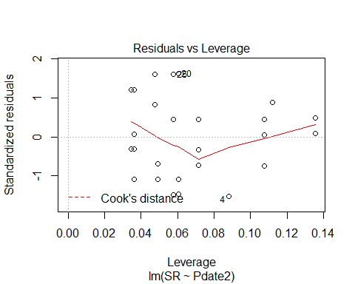

Pdate3<-(methodSR1$Pdate)^3  
evaluation4C<-lm(SR ~ Pdate3, methodSR1) #non-significant  
summary(evaluation4C)

##   
## Call:  
## lm(formula = SR ~ Pdate3, data = methodSR1)  
##   
## Residuals:  
## Min 1Q Median 3Q Max   
## -3.8595 -1.8649 0.1784 2.1568 4.1946   
##   
## Coefficients:  
## Estimate Std. Error t value Pr(>|t|)  
## (Intercept) -6.396e+01 1.505e+03 -0.042 0.966  
## Pdate3 9.656e-13 1.869e-11 0.052 0.959  
##   
## Residual standard error: 2.667 on 27 degrees of freedom  
## (29 observations deleted due to missingness)  
## Multiple R-squared: 9.888e-05, Adjusted R-squared: -0.03693   
## F-statistic: 0.00267 on 1 and 27 DF, p-value: 0.9592

confint(evaluation4C, level=0.95)

## 2.5 % 97.5 %  
## (Intercept) -3.152971e+03 3.025043e+03  
## Pdate3 -3.737827e-11 3.930953e-11

anova(evaluation4C)

## Analysis of Variance Table  
##   
## Response: SR  
## Df Sum Sq Mean Sq F value Pr(>F)  
## Pdate3 1 0.019 0.0190 0.0027 0.9592  
## Residuals 27 192.119 7.1155

plot(evaluation4C)

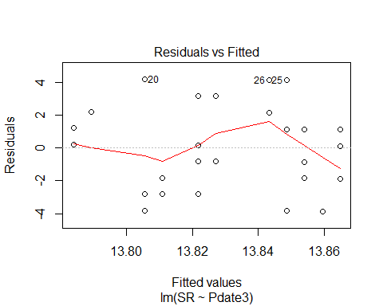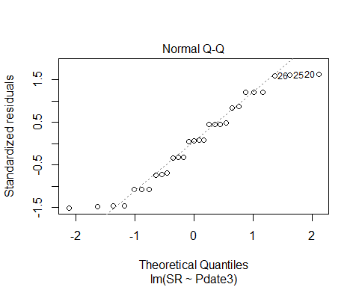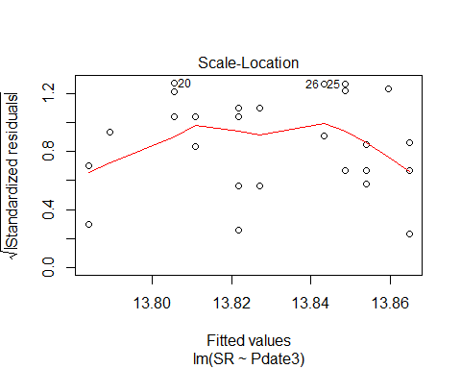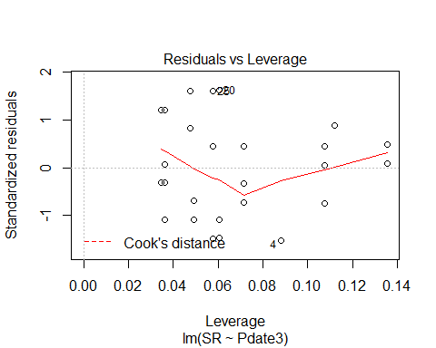

evaluation5<-lm(SR ~ Pmin, methodSR1) #significant + linear relationship   
summary(evaluation5)

##   
## Call:  
## lm(formula = SR ~ Pmin, data = methodSR1)  
##   
## Residuals:  
## Min 1Q Median 3Q Max   
## -4.3312 -1.6130 0.2438 1.5256 3.9575   
##   
## Coefficients:  
## Estimate Std. Error t value Pr(>|t|)   
## (Intercept) 10.17878 1.02969 9.885 1.82e-10 ***  
## Pmin 0.14319 0.03726 3.843 0.00067 ***  
## ---  
## Signif. codes: 0 '***' 0.001 '**' 0.01 '*' 0.05 '.' 0.1 ' ' 1  
##   
## Residual standard error: 2.145 on 27 degrees of freedom  
## (29 observations deleted due to missingness)  
## Multiple R-squared: 0.3535, Adjusted R-squared: 0.3296   
## F-statistic: 14.77 on 1 and 27 DF, p-value: 0.00067

confint(evaluation5, level=0.95)

## 2.5 % 97.5 %  
## (Intercept) 8.06603845 12.2915237  
## Pmin 0.06673188 0.2196425

anova(evaluation5)

## Analysis of Variance Table  
##   
## Response: SR  
## Df Sum Sq Mean Sq F value Pr(>F)   
## Pmin 1 67.93 67.93 14.766 0.00067 ***  
## Residuals 27 124.21 4.60   
## ---  
## Signif. codes: 0 '***' 0.001 '**' 0.01 '*' 0.05 '.' 0.1 ' ' 1

plot(evaluation5)

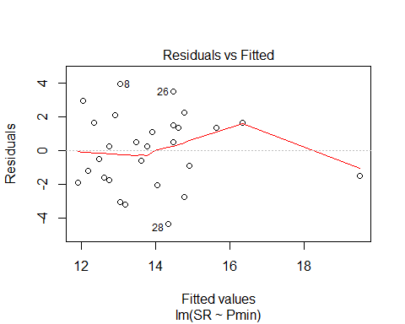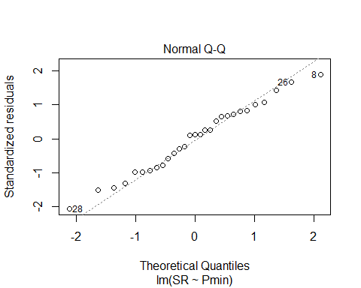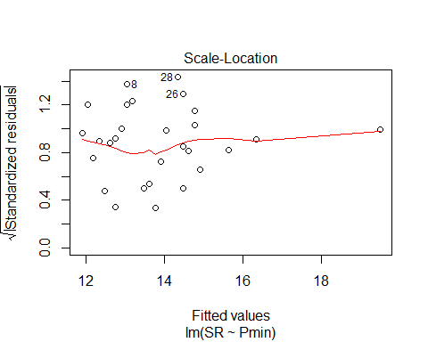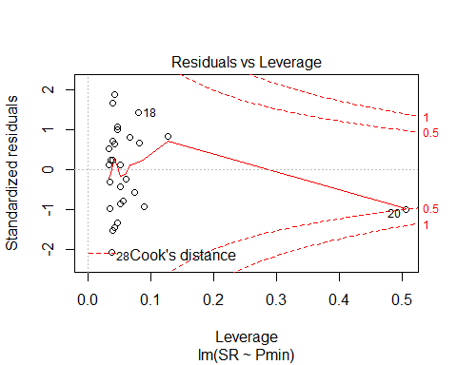

evaluation6<-lm(SR ~ Peffort, methodSR1) #significant + linear relationship  
summary(evaluation6)

##   
## Call:  
## lm(formula = SR ~ Peffort, data = methodSR1)  
##   
## Residuals:  
## Min 1Q Median 3Q Max   
## -4.8147 -1.4834 0.2791 1.6603 4.8979   
##   
## Coefficients:  
## Estimate Std. Error t value Pr(>|t|)   
## (Intercept) 11.8646 0.8140 14.576 2.57e-14 ***  
## Peffort 0.6188 0.2170 2.851 0.00825 **   
## ---  
## Signif. codes: 0 '***' 0.001 '**' 0.01 '*' 0.05 '.' 0.1 ' ' 1  
##   
## Residual standard error: 2.339 on 27 degrees of freedom  
## (29 observations deleted due to missingness)  
## Multiple R-squared: 0.2314, Adjusted R-squared: 0.203   
## F-statistic: 8.13 on 1 and 27 DF, p-value: 0.008245

confint(evaluation6, level=0.95)

## 2.5 % 97.5 %  
## (Intercept) 10.1944675 13.534749  
## Peffort 0.1734964 1.064033

anova(evaluation6)

## Analysis of Variance Table  
##   
## Response: SR  
## Df Sum Sq Mean Sq F value Pr(>F)   
## Peffort 1 44.466 44.466 8.13 0.008245 **  
## Residuals 27 147.672 5.469   
## ---  
## Signif. codes: 0 '***' 0.001 '**' 0.01 '*' 0.05 '.' 0.1 ' ' 1

plot(evaluation6)

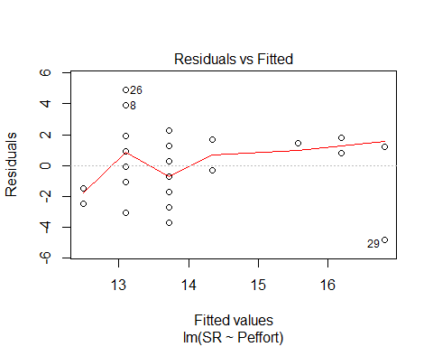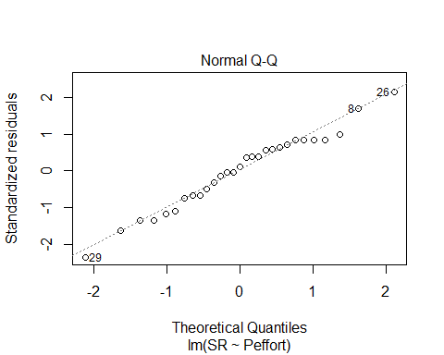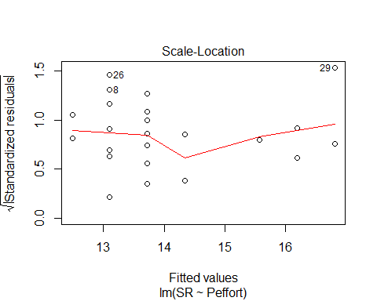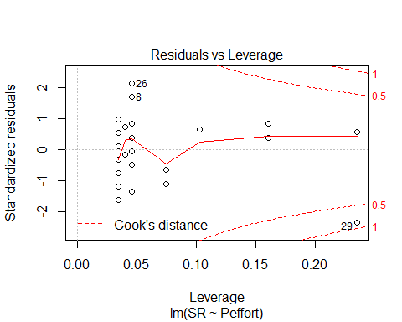

Peffort2<-(methodSR1$Peffort)^2  
evaluation6B<-lm(SR ~ Peffort2, methodSR1) #significant + linear relationship  
summary(evaluation6B)

##   
## Call:  
## lm(formula = SR ~ Peffort2, data = methodSR1)  
##   
## Residuals:  
## Min 1Q Median 3Q Max   
## -4.8789 -2.0289 0.4822 1.7877 4.7877   
##   
## Coefficients:  
## Estimate Std. Error t value Pr(>|t|)   
## (Intercept) 12.96782 0.56083 23.122 <2e-16 ***  
## Peffort2 0.06111 0.02421 2.524 0.0178 *   
## ---  
## Signif. codes: 0 '***' 0.001 '**' 0.01 '*' 0.05 '.' 0.1 ' ' 1  
##   
## Residual standard error: 2.399 on 27 degrees of freedom  
## (29 observations deleted due to missingness)  
## Multiple R-squared: 0.1909, Adjusted R-squared: 0.161   
## F-statistic: 6.372 on 1 and 27 DF, p-value: 0.01778

confint(evaluation6B, level=0.95)

## 2.5 % 97.5 %  
## (Intercept) 11.81708282 14.1185560  
## Peffort2 0.01143857 0.1107832

anova(evaluation6B)

## Analysis of Variance Table  
##   
## Response: SR  
## Df Sum Sq Mean Sq F value Pr(>F)   
## Peffort2 1 36.688 36.688 6.3722 0.01778 *  
## Residuals 27 155.450 5.757   
## ---  
## Signif. codes: 0 '***' 0.001 '**' 0.01 '*' 0.05 '.' 0.1 ' ' 1

plot(evaluation6B)

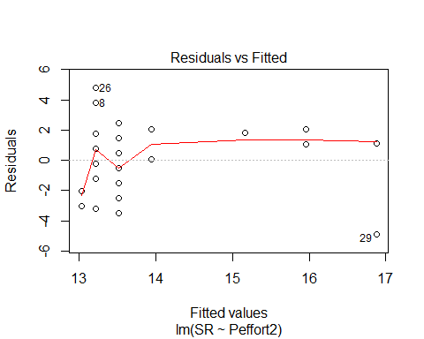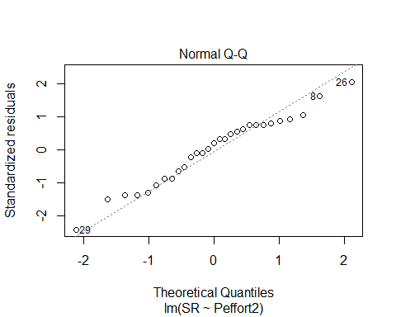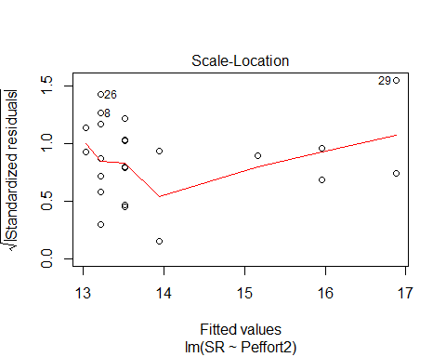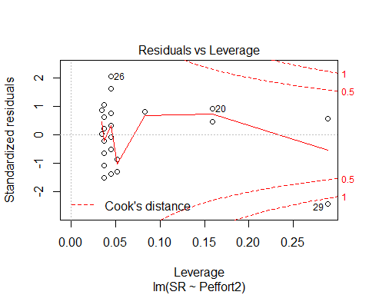

Peffort3<-(methodSR1$Peffort)^3  
evaluation6C<-lm(SR ~ Peffort3, methodSR1) #significant + linear relationship  
summary(evaluation6C)

##   
## Call:  
## lm(formula = SR ~ Peffort3, data = methodSR1)  
##   
## Residuals:  
## Min 1Q Median 3Q Max   
## -4.8269 -2.2729 0.5463 1.6784 4.6784   
##   
## Coefficients:  
## Estimate Std. Error t value Pr(>|t|)   
## (Intercept) 13.265910 0.517922 25.614 <2e-16 ***  
## Peffort3 0.006955 0.003079 2.259 0.0322 *   
## ---  
## Signif. codes: 0 '***' 0.001 '**' 0.01 '*' 0.05 '.' 0.1 ' ' 1  
##   
## Residual standard error: 2.447 on 27 degrees of freedom  
## (29 observations deleted due to missingness)  
## Multiple R-squared: 0.1589, Adjusted R-squared: 0.1277   
## F-statistic: 5.101 on 1 and 27 DF, p-value: 0.0322

confint(evaluation6C, level=0.95)

## 2.5 % 97.5 %  
## (Intercept) 1.220322e+01 14.32859766  
## Peffort3 6.364656e-04 0.01327352

anova(evaluation6C)

## Analysis of Variance Table  
##   
## Response: SR  
## Df Sum Sq Mean Sq F value Pr(>F)   
## Peffort3 1 30.531 30.5310 5.1009 0.0322 *  
## Residuals 27 161.607 5.9854   
## ---  
## Signif. codes: 0 '***' 0.001 '**' 0.01 '*' 0.05 '.' 0.1 ' ' 1

plot(evaluation6C)

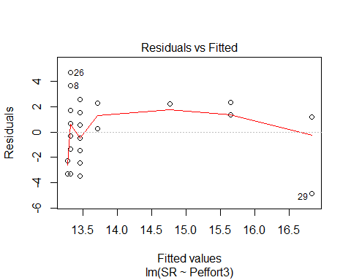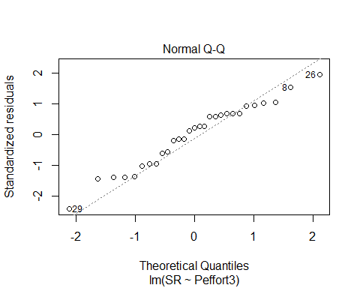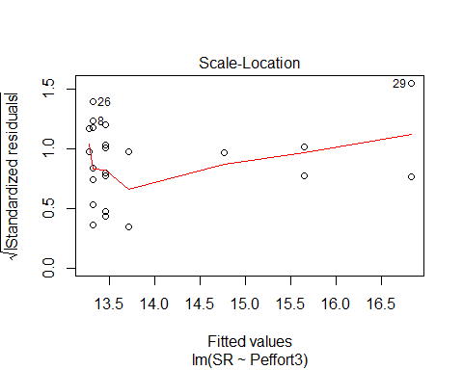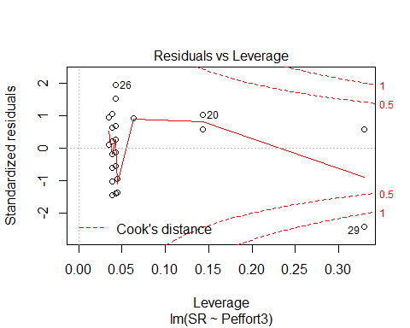

# Visit 2

#File read-in  
# as of 6/22, this one-visit breakdown has had unknowns REMOVED now (in both AC + PC)  
methodSR2 <-read.csv("17_2by2_ACPC_SR.csv") #SR by count #2 each - Site Type SR  
#summary(methodSR2)  
str(methodSR2)

## 'data.frame': 58 obs. of 9 variables:  
## $ SiteName: Factor w/ 29 levels "Abercrombie_0B_E_AB",..: 3 4 5 7 8 12 13 14 15 16 ...  
## $ Type : Factor w/ 2 levels "AC","PC": 1 1 1 1 1 1 1 1 1 1 ...  
## $ SR : int 17 15 12 9 9 16 13 11 17 13 ...  
## $ Sdate : int 2 17 28 36 22 25 35 28 9 22 ...  
## $ Stime : int 426 353 553 355 354 558 386 425 521 514 ...  
## $ Pdate : int 43201 43201 43203 43209 43210 43202 43205 43205 43206 43205 ...  
## $ Pmin : int 39 25 37 14 15 15 18 22 15 21 ...  
## $ Peffort : int 4 3 7 1 1 2 2 2 2 2 ...  
## $ Year : Factor w/ 1 level "A": 1 1 1 1 1 1 1 1 1 1 ...

plot(methodSR2$SR ~ methodSR2$Type) #more equalized

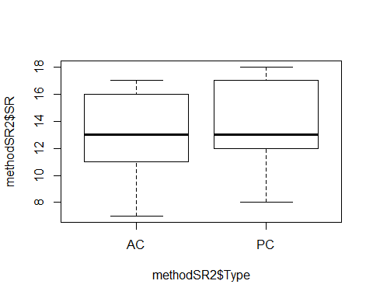

#plot(SR ~ Type, data=methodSR) #same as above

evaluation7<-lm(SR ~ Type, methodSR2) #non-sig  
summary(evaluation7)

##   
## Call:  
## lm(formula = SR ~ Type, data = methodSR2)  
##   
## Residuals:  
## Min 1Q Median 3Q Max   
## -6.3793 -1.9655 -0.3793 3.0345 4.0345   
##   
## Coefficients:  
## Estimate Std. Error t value Pr(>|t|)   
## (Intercept) 13.3793 0.5435 24.615 <2e-16 ***  
## TypePC 0.5862 0.7687 0.763 0.449   
## ---  
## Signif. codes: 0 '***' 0.001 '**' 0.01 '*' 0.05 '.' 0.1 ' ' 1  
##   
## Residual standard error: 2.927 on 56 degrees of freedom  
## Multiple R-squared: 0.01028, Adjusted R-squared: -0.007395   
## F-statistic: 0.5816 on 1 and 56 DF, p-value: 0.4489

confint(evaluation7, level=0.95)

## 2.5 % 97.5 %  
## (Intercept) 12.2904627 14.46816  
## TypePC -0.9536563 2.12607

anova(evaluation7)

## Analysis of Variance Table  
##   
## Response: SR  
## Df Sum Sq Mean Sq F value Pr(>F)  
## Type 1 4.98 4.9828 0.5816 0.4489  
## Residuals 56 479.79 8.5677

evaluation8<-lm(SR ~ Sdate, methodSR2) #non-signficant  
summary(evaluation8)

##   
## Call:  
## lm(formula = SR ~ Sdate, data = methodSR2)  
##   
## Residuals:  
## Min 1Q Median 3Q Max   
## -5.9232 -1.8455 -0.4475 2.6715 4.5720   
##   
## Coefficients:  
## Estimate Std. Error t value Pr(>|t|)   
## (Intercept) 12.84556 0.95397 13.465 <2e-16 ***  
## Sdate 0.03883 0.04103 0.947 0.348   
## ---  
## Signif. codes: 0 '***' 0.001 '**' 0.01 '*' 0.05 '.' 0.1 ' ' 1  
##   
## Residual standard error: 2.919 on 56 degrees of freedom  
## Multiple R-squared: 0.01575, Adjusted R-squared: -0.00183   
## F-statistic: 0.8959 on 1 and 56 DF, p-value: 0.348

confint(evaluation8, level=0.95)

## 2.5 % 97.5 %  
## (Intercept) 10.93452241 14.7565916  
## Sdate -0.04335454 0.1210188

anova(evaluation8)

## Analysis of Variance Table  
##   
## Response: SR  
## Df Sum Sq Mean Sq F value Pr(>F)  
## Sdate 1 7.63 7.6332 0.8959 0.348  
## Residuals 56 477.14 8.5204

evaluation9<-lm(SR ~ Stime, methodSR2) #non-signficant  
summary(evaluation9)

##   
## Call:  
## lm(formula = SR ~ Stime, data = methodSR2)  
##   
## Residuals:  
## Min 1Q Median 3Q Max   
## -6.9175 -1.6896 -0.5347 3.1973 4.4687   
##   
## Coefficients:  
## Estimate Std. Error t value Pr(>|t|)   
## (Intercept) 12.911893 2.660799 4.853 1.01e-05 ***  
## Stime 0.001740 0.006022 0.289 0.774   
## ---  
## Signif. codes: 0 '***' 0.001 '**' 0.01 '*' 0.05 '.' 0.1 ' ' 1  
##   
## Residual standard error: 2.94 on 56 degrees of freedom  
## Multiple R-squared: 0.001488, Adjusted R-squared: -0.01634   
## F-statistic: 0.08345 on 1 and 56 DF, p-value: 0.7737

confint(evaluation9, level=0.95)

## 2.5 % 97.5 %  
## (Intercept) 7.58167139 18.24211500  
## Stime -0.01032466 0.01380421

anova(evaluation9)

## Analysis of Variance Table  
##   
## Response: SR  
## Df Sum Sq Mean Sq F value Pr(>F)  
## Stime 1 0.72 0.7213 0.0835 0.7737  
## Residuals 56 484.05 8.6438

evaluation10<-lm(SR ~ Pdate, methodSR2) #non-signficant  
summary(evaluation10)

##   
## Call:  
## lm(formula = SR ~ Pdate, data = methodSR2)  
##   
## Residuals:  
## Min 1Q Median 3Q Max   
## -5.7685 -2.2651 -0.0929 2.9071 4.3970   
##   
## Coefficients:  
## Estimate Std. Error t value Pr(>|t|)  
## (Intercept) -7139.1104 8308.4341 -0.859 0.398  
## Pdate 0.1655 0.1923 0.861 0.397  
##   
## Residual standard error: 3.078 on 27 degrees of freedom  
## (29 observations deleted due to missingness)  
## Multiple R-squared: 0.02671, Adjusted R-squared: -0.009333   
## F-statistic: 0.7411 on 1 and 27 DF, p-value: 0.3969

confint(evaluation10, level=0.95)

## 2.5 % 97.5 %  
## (Intercept) -24186.608951 9908.3882241  
## Pdate -0.229021 0.5601111

anova(evaluation10)

## Analysis of Variance Table  
##   
## Response: SR  
## Df Sum Sq Mean Sq F value Pr(>F)  
## Pdate 1 7.021 7.0214 0.7411 0.3969  
## Residuals 27 255.806 9.4743

evaluation11<-lm(SR ~ Pmin, methodSR2) #non-signficant  
summary(evaluation11)

##   
## Call:  
## lm(formula = SR ~ Pmin, data = methodSR2)  
##   
## Residuals:  
## Min 1Q Median 3Q Max   
## -5.968 -2.264 -0.190 3.033 4.181   
##   
## Coefficients:  
## Estimate Std. Error t value Pr(>|t|)   
## (Intercept) 11.85476 1.64894 7.189 9.88e-08 ***  
## Pmin 0.07418 0.07530 0.985 0.333   
## ---  
## Signif. codes: 0 '***' 0.001 '**' 0.01 '*' 0.05 '.' 0.1 ' ' 1  
##   
## Residual standard error: 3.065 on 27 degrees of freedom  
## (29 observations deleted due to missingness)  
## Multiple R-squared: 0.0347, Adjusted R-squared: -0.001056   
## F-statistic: 0.9705 on 1 and 27 DF, p-value: 0.3333

confint(evaluation11, level=0.95)

## 2.5 % 97.5 %  
## (Intercept) 8.47142147 15.2380962  
## Pmin -0.08032403 0.2286864

anova(evaluation11)

## Analysis of Variance Table  
##   
## Response: SR  
## Df Sum Sq Mean Sq F value Pr(>F)  
## Pmin 1 9.119 9.1192 0.9705 0.3333  
## Residuals 27 253.708 9.3966

evaluation12<-lm(SR ~ Peffort, methodSR2) #signficant + linear relationship!  
summary(evaluation12)

##   
## Call:  
## lm(formula = SR ~ Peffort, data = methodSR2)  
##   
## Residuals:  
## Min 1Q Median 3Q Max   
## -5.9344 -2.1874 -0.1874 2.8126 4.0656   
##   
## Coefficients:  
## Estimate Std. Error t value Pr(>|t|)   
## (Intercept) 12.6814 0.9932 12.769 5.92e-13 ***  
## Peffort 0.2530 0.2944 0.859 0.398   
## ---  
## Signif. codes: 0 '***' 0.001 '**' 0.01 '*' 0.05 '.' 0.1 ' ' 1  
##   
## Residual standard error: 3.078 on 27 degrees of freedom  
## (29 observations deleted due to missingness)  
## Multiple R-squared: 0.02662, Adjusted R-squared: -0.00943   
## F-statistic: 0.7384 on 1 and 27 DF, p-value: 0.3977

confint(evaluation12, level=0.95)

## 2.5 % 97.5 %  
## (Intercept) 10.6435791 14.7191969  
## Peffort -0.3510985 0.8570922

anova(evaluation12)

## Analysis of Variance Table  
##   
## Response: SR  
## Df Sum Sq Mean Sq F value Pr(>F)  
## Peffort 1 6.997 6.9967 0.7384 0.3977  
## Residuals 27 255.831 9.4752

# Visit 3

#File read-in  
# as of 6/22, this one-visit breakdown has had unknowns REMOVED now (in both AC + PC)  
methodSR3 <-read.csv("17_3by3_ACPC_SR.csv") #SR by count #3 each - Site Type SR  
#summary(methodSR3)  
str(methodSR3)

## 'data.frame': 58 obs. of 9 variables:  
## $ SiteName: Factor w/ 29 levels "Abercrombie_0B_E_AB",..: 3 4 5 7 8 12 13 14 15 16 ...  
## $ Type : Factor w/ 2 levels "AC","PC": 1 1 1 1 1 1 1 1 1 1 ...  
## $ SR : int 10 16 11 16 16 16 14 14 15 14 ...  
## $ Sdate : int 15 18 47 33 22 33 34 29 10 20 ...  
## $ Stime : int 363 500 380 513 559 507 526 359 395 566 ...  
## $ Pdate : int 43214 43214 43216 43219 43220 43215 43216 43216 43217 43216 ...  
## $ Pmin : int 18 15 14 27 12 26 14 19 24 19 ...  
## $ Peffort : int 1 2 2 7 2 8 2 4 5 5 ...  
## $ Year : Factor w/ 1 level "A": 1 1 1 1 1 1 1 1 1 1 ...

plot(methodSR3$SR ~ methodSR3$Type) #

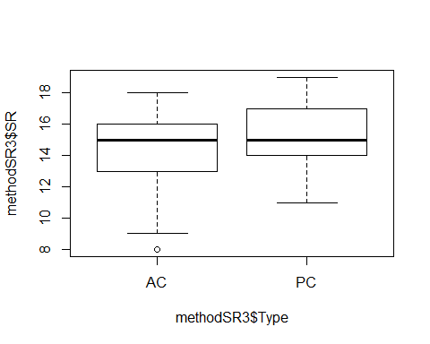

#plot(SR ~ Type, data=methodSR) #same as above

evaluation13<-lm(SR ~ Type, methodSR3) #non-significant  
summary(evaluation13)

##   
## Call:  
## lm(formula = SR ~ Type, data = methodSR3)  
##   
## Residuals:  
## Min 1Q Median 3Q Max   
## -6.4828 -1.1724 0.5172 1.5172 3.8276   
##   
## Coefficients:  
## Estimate Std. Error t value Pr(>|t|)   
## (Intercept) 14.4828 0.4449 32.556 <2e-16 ***  
## TypePC 0.6897 0.6291 1.096 0.278   
## ---  
## Signif. codes: 0 '***' 0.001 '**' 0.01 '*' 0.05 '.' 0.1 ' ' 1  
##   
## Residual standard error: 2.396 on 56 degrees of freedom  
## Multiple R-squared: 0.02101, Adjusted R-squared: 0.003526   
## F-statistic: 1.202 on 1 and 56 DF, p-value: 0.2777

confint(evaluation13, level=0.95)

## 2.5 % 97.5 %  
## (Intercept) 13.5916122 15.373905  
## TypePC -0.5706162 1.949927

anova(evaluation13)

## Analysis of Variance Table  
##   
## Response: SR  
## Df Sum Sq Mean Sq F value Pr(>F)  
## Type 1 6.90 6.8966 1.2017 0.2777  
## Residuals 56 321.38 5.7389

evaluation14<-lm(SR ~ Sdate, methodSR3) #non-significant  
summary(evaluation14)

##   
## Call:  
## lm(formula = SR ~ Sdate, data = methodSR3)  
##   
## Residuals:  
## Min 1Q Median 3Q Max   
## -6.9003 -0.8524 0.1678 1.1720 4.1465   
##   
## Coefficients:  
## Estimate Std. Error t value Pr(>|t|)   
## (Intercept) 14.981252 0.390418 38.372 <2e-16 ***  
## Sdate -0.004258 0.006329 -0.673 0.504   
## ---  
## Signif. codes: 0 '***' 0.001 '**' 0.01 '*' 0.05 '.' 0.1 ' ' 1  
##   
## Residual standard error: 2.411 on 56 degrees of freedom  
## Multiple R-squared: 0.008018, Adjusted R-squared: -0.009696   
## F-statistic: 0.4527 on 1 and 56 DF, p-value: 0.5038

confint(evaluation14, level=0.95)

## 2.5 % 97.5 %  
## (Intercept) 14.19915199 15.763352555  
## Sdate -0.01693734 0.008420727

anova(evaluation14)

## Analysis of Variance Table  
##   
## Response: SR  
## Df Sum Sq Mean Sq F value Pr(>F)  
## Sdate 1 2.63 2.6322 0.4527 0.5038  
## Residuals 56 325.64 5.8151

evaluation15<-lm(SR ~ Stime, methodSR3) #significant +!  
summary(evaluation15)

##   
## Call:  
## lm(formula = SR ~ Stime, data = methodSR3)  
##   
## Residuals:  
## Min 1Q Median 3Q Max   
## -5.9696 -1.2562 0.0823 1.4125 4.6254   
##   
## Coefficients:  
## Estimate Std. Error t value Pr(>|t|)   
## (Intercept) 10.23114 2.21645 4.616 2.33e-05 ***  
## Stime 0.01039 0.00496 2.094 0.0408 *   
## ---  
## Signif. codes: 0 '***' 0.001 '**' 0.01 '*' 0.05 '.' 0.1 ' ' 1  
##   
## Residual standard error: 2.332 on 56 degrees of freedom  
## Multiple R-squared: 0.07261, Adjusted R-squared: 0.05605   
## F-statistic: 4.384 on 1 and 56 DF, p-value: 0.04081

confint(evaluation15, level=0.95)

## 2.5 % 97.5 %  
## (Intercept) 5.7910620421 14.6712080  
## Stime 0.0004494594 0.0203198

anova(evaluation15)

## Analysis of Variance Table  
##   
## Response: SR  
## Df Sum Sq Mean Sq F value Pr(>F)   
## Stime 1 23.835 23.8349 4.3843 0.04081 *  
## Residuals 56 304.441 5.4364   
## ---  
## Signif. codes: 0 '***' 0.001 '**' 0.01 '*' 0.05 '.' 0.1 ' ' 1

plot(SR ~ Stime, methodSR3)

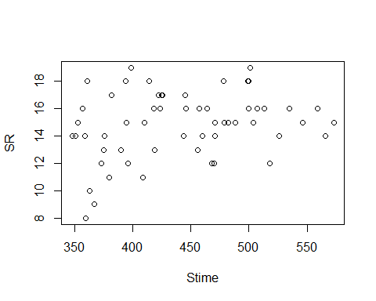

plot(evaluation15)

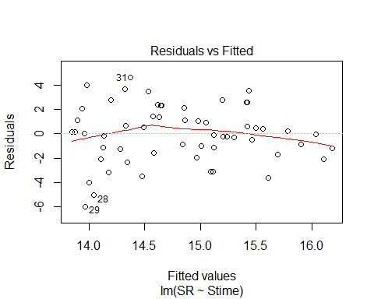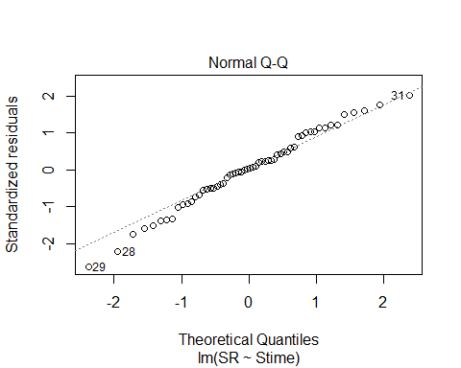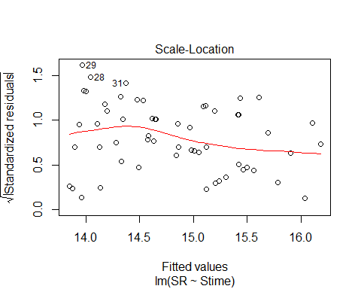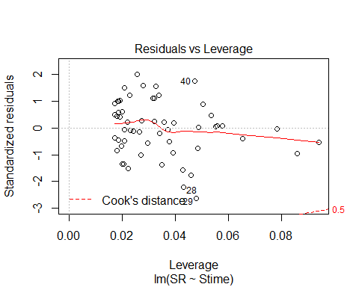

evaluation16<-lm(SR ~ Pdate, methodSR3) #significant +!  
summary(evaluation16)

##   
## Call:  
## lm(formula = SR ~ Pdate, data = methodSR3)  
##   
## Residuals:  
## Min 1Q Median 3Q Max   
## -5.8546 -0.8906 0.1454 0.8684 3.6634   
##   
## Coefficients:  
## Estimate Std. Error t value Pr(>|t|)   
## (Intercept) -3.279e+04 9.885e+03 -3.317 0.00261 **  
## Pdate 7.590e-01 2.287e-01 3.318 0.00260 **  
## ---  
## Signif. codes: 0 '***' 0.001 '**' 0.01 '*' 0.05 '.' 0.1 ' ' 1  
##   
## Residual standard error: 2.171 on 27 degrees of freedom  
## (29 observations deleted due to missingness)  
## Multiple R-squared: 0.2897, Adjusted R-squared: 0.2634   
## F-statistic: 11.01 on 1 and 27 DF, p-value: 0.002597

confint(evaluation16, level=0.95)

## 2.5 % 97.5 %  
## (Intercept) -5.306816e+04 -12505.154898  
## Pdate 2.896936e-01 1.228287

anova(evaluation16)

## Analysis of Variance Table  
##   
## Response: SR  
## Df Sum Sq Mean Sq F value Pr(>F)   
## Pdate 1 51.925 51.925 11.012 0.002597 **  
## Residuals 27 127.316 4.715   
## ---  
## Signif. codes: 0 '***' 0.001 '**' 0.01 '*' 0.05 '.' 0.1 ' ' 1

plot(SR ~ Pdate, methodSR3)

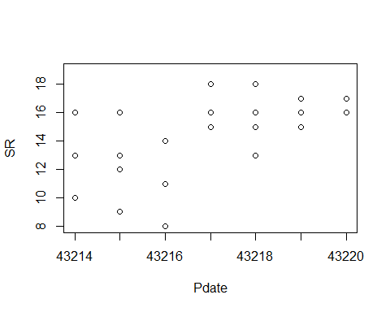

plot(evaluation16)

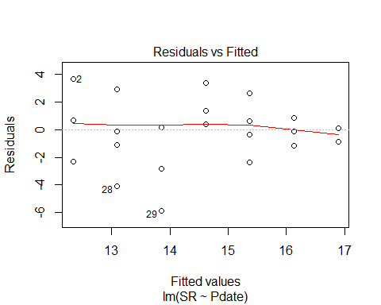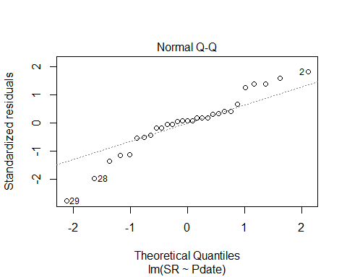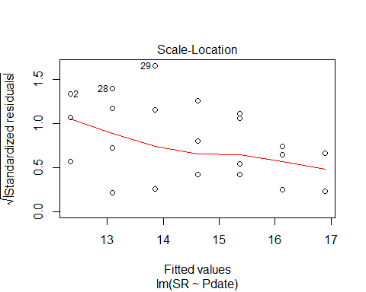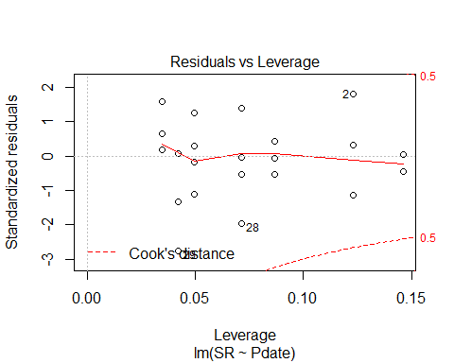

evaluation17<-lm(SR ~ Pmin, methodSR3) #non-significant  
summary(evaluation17)

##   
## Call:  
## lm(formula = SR ~ Pmin, data = methodSR3)  
##   
## Residuals:  
## Min 1Q Median 3Q Max   
## -6.3405 -1.4081 0.5581 1.5919 3.6257   
##   
## Coefficients:  
## Estimate Std. Error t value Pr(>|t|)   
## (Intercept) 13.93455 1.81783 7.666 3.03e-08 ***  
## Pmin 0.03383 0.10822 0.313 0.757   
## ---  
## Signif. codes: 0 '***' 0.001 '**' 0.01 '*' 0.05 '.' 0.1 ' ' 1  
##   
## Residual standard error: 2.572 on 27 degrees of freedom  
## (29 observations deleted due to missingness)  
## Multiple R-squared: 0.003605, Adjusted R-squared: -0.0333   
## F-statistic: 0.09769 on 1 and 27 DF, p-value: 0.757

confint(evaluation17, level=0.95)

## 2.5 % 97.5 %  
## (Intercept) 10.2046756 17.6644171  
## Pmin -0.1882304 0.2558821

anova(evaluation17)

## Analysis of Variance Table  
##   
## Response: SR  
## Df Sum Sq Mean Sq F value Pr(>F)  
## Pmin 1 0.646 0.6462 0.0977 0.757  
## Residuals 27 178.595 6.6146

evaluation18<-lm(SR ~ Peffort, methodSR3) #close but not sig  
summary(evaluation18)

##   
## Call:  
## lm(formula = SR ~ Peffort, data = methodSR3)  
##   
## Residuals:  
## Min 1Q Median 3Q Max   
## -5.9905 -1.0479 0.1591 1.7451 4.0095   
##   
## Coefficients:  
## Estimate Std. Error t value Pr(>|t|)   
## (Intercept) 13.7262 0.8335 16.467 1.32e-15 ***  
## Peffort 0.2643 0.2410 1.097 0.282   
## ---  
## Signif. codes: 0 '***' 0.001 '**' 0.01 '*' 0.05 '.' 0.1 ' ' 1  
##   
## Residual standard error: 2.521 on 27 degrees of freedom  
## (29 observations deleted due to missingness)  
## Multiple R-squared: 0.04267, Adjusted R-squared: 0.007209   
## F-statistic: 1.203 on 1 and 27 DF, p-value: 0.2823

confint(evaluation18, level=0.95)

## 2.5 % 97.5 %  
## (Intercept) 12.0159150 15.4365110  
## Peffort -0.2300962 0.7587666

anova(evaluation18)

## Analysis of Variance Table  
##   
## Response: SR  
## Df Sum Sq Mean Sq F value Pr(>F)  
## Peffort 1 7.647 7.6475 1.2033 0.2823  
## Residuals 27 171.594 6.3553

# 3 visits pooled 2017 - redone with only 3 PC visits this time (not 4)

#File read-in  
# UNKNS NOT INCLUDED IN THIS!  
methodOSR <-read.csv("17_all3_ACPC_SR.csv") #SR by 3 counts pooled SR with unkns extracted  
#summary(methodOSR)  
str(methodOSR)

## 'data.frame': 58 obs. of 3 variables:  
## $ SiteName: Factor w/ 29 levels "Abercrombie_0B_E_AB",..: 3 4 5 7 8 12 13 14 15 16 ...  
## $ Type : Factor w/ 2 levels "AC","PC": 1 1 1 1 1 1 1 1 1 1 ...  
## $ SR : int 23 22 18 24 23 25 23 26 24 21 ...

plot(methodOSR$SR ~ methodOSR$Type)

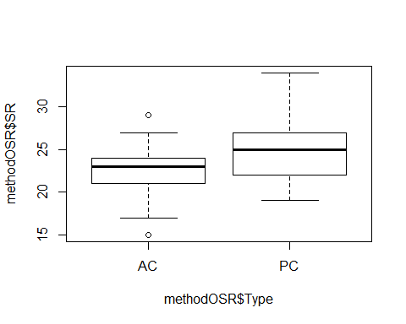

evaluationOSR<-lm(SR ~ Type, methodOSR)  
summary(evaluationOSR)

##   
## Call:  
## lm(formula = SR ~ Type, data = methodOSR)  
##   
## Residuals:  
## Min 1Q Median 3Q Max   
## -7.5517 -2.2069 0.1207 1.7069 8.7931   
##   
## Coefficients:  
## Estimate Std. Error t value Pr(>|t|)   
## (Intercept) 22.552 0.664 33.965 < 2e-16 ***  
## TypePC 2.655 0.939 2.828 0.00649 **   
## ---  
## Signif. codes: 0 '***' 0.001 '**' 0.01 '*' 0.05 '.' 0.1 ' ' 1  
##   
## Residual standard error: 3.576 on 56 degrees of freedom  
## Multiple R-squared: 0.1249, Adjusted R-squared: 0.1093   
## F-statistic: 7.996 on 1 and 56 DF, p-value: 0.006492

confint(evaluationOSR, level=0.95)

## 2.5 % 97.5 %  
## (Intercept) 21.2216504 23.881798  
## TypePC 0.7741641 4.536181

anova(evaluationOSR)

## Analysis of Variance Table  
##   
## Response: SR  
## Df Sum Sq Mean Sq F value Pr(>F)   
## Type 1 102.22 102.224 7.996 0.006492 **  
## Residuals 56 715.93 12.784   
## ---  
## Signif. codes: 0 '***' 0.001 '**' 0.01 '*' 0.05 '.' 0.1 ' ' 1

#### 2018 on its own

#File read-in  
# updated 8/27 - unknowns REMOVED (in both AC + PC)  
methodSR1 <-read.csv("18_1by1_ACPC_SR.csv") #SR by 1 visit each - Site Type SR  
summary(methodSR1)

## SiteName Type SR Sdate   
## Battlewood_1B_8: 2 AC:30 Min. : 9.00 Min. : 4.00   
## Blease_3B_6 : 2 PC:30 1st Qu.:14.00 1st Qu.: 7.75   
## Blease_3B_9 : 2 Median :16.50 Median :11.00   
## Bryson_2B_9 : 2 Mean :16.47 Mean :16.18   
## Burnett_1B_5 : 2 3rd Qu.:19.00 3rd Qu.:24.25   
## Creswell_0B_8 : 2 Max. :23.00 Max. :41.00   
## (Other) :48   
## Stime Pdate Pmin Peffort Year   
## Min. :352.0 Min. :43314 Min. :12.00 Min. :1.000 B:60   
## 1st Qu.:390.2 1st Qu.:43315 1st Qu.:13.00 1st Qu.:1.000   
## Median :446.0 Median :43318 Median :13.00 Median :2.000   
## Mean :447.4 Mean :43318 Mean :14.23 Mean :1.667   
## 3rd Qu.:501.2 3rd Qu.:43320 3rd Qu.:15.75 3rd Qu.:2.000   
## Max. :568.0 Max. :43325 Max. :25.00 Max. :3.000   
## NA's :30 NA's :30 NA's :30

str(methodSR1)

## 'data.frame': 60 obs. of 9 variables:  
## $ SiteName: Factor w/ 30 levels "Battlewood_1B_8",..: 1 2 3 4 5 6 7 8 9 10 ...  
## $ Type : Factor w/ 2 levels "AC","PC": 1 1 1 1 1 1 1 1 1 1 ...  
## $ SR : int 16 15 12 12 14 10 15 11 12 15 ...  
## $ Sdate : int 41 20 32 6 6 34 29 36 35 24 ...  
## $ Stime : int 511 499 354 407 485 391 509 364 400 352 ...  
## $ Pdate : int 43325 43317 43320 43314 43314 43320 43318 43325 43325 43317 ...  
## $ Pmin : int 12 15 16 13 16 12 13 12 12 13 ...  
## $ Peffort : int 3 2 2 1 2 1 1 1 1 1 ...  
## $ Year : Factor w/ 1 level "B": 1 1 1 1 1 1 1 1 1 1 ...

#plot(methodSR1$SR ~ methodSR1$Type) #same as below  
plot(SR ~ Type, data=methodSR1)

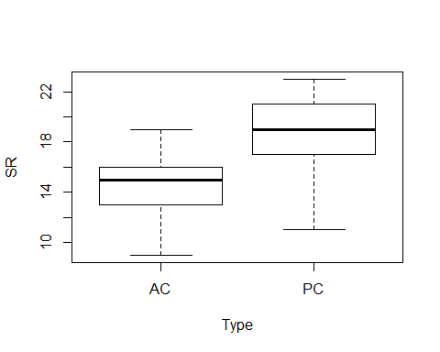

plot(SR ~ Sdate, data=methodSR1)

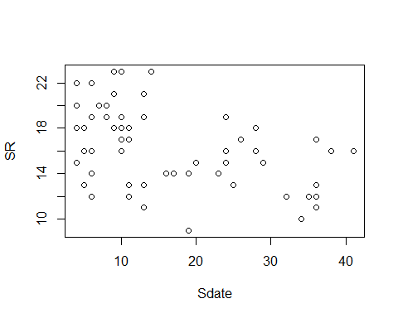

plot(SR ~ Stime, data=methodSR1)

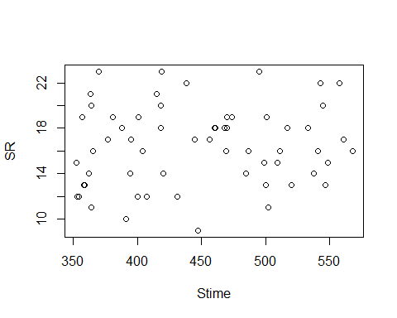

plot(SR ~ Pdate, data=methodSR1)

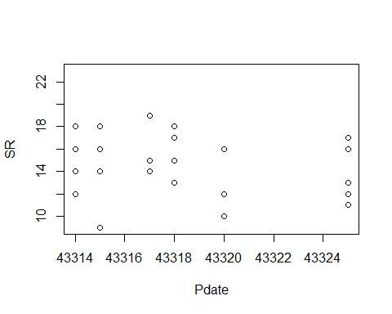

plot(SR ~ Pmin, data=methodSR1)

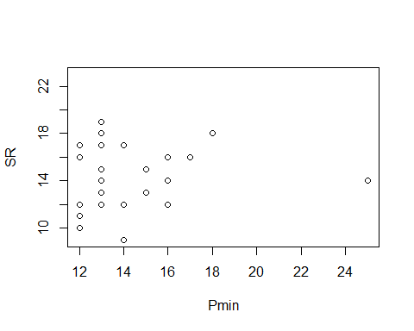

plot(SR ~ Peffort, data=methodSR1)

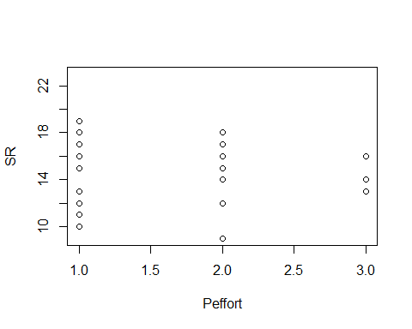

evaluation1<-lm(SR ~ Type, methodSR1) #sig  
summary(evaluation1)

##   
## Call:  
## lm(formula = SR ~ Type, data = methodSR1)  
##   
## Residuals:  
## Min 1Q Median 3Q Max   
## -7.3000 -1.6333 0.3667 1.8667 4.7000   
##   
## Coefficients:  
## Estimate Std. Error t value Pr(>|t|)   
## (Intercept) 14.6333 0.5431 26.943 < 2e-16 ***  
## TypePC 3.6667 0.7681 4.774 1.27e-05 ***  
## ---  
## Signif. codes: 0 '***' 0.001 '**' 0.01 '*' 0.05 '.' 0.1 ' ' 1  
##   
## Residual standard error: 2.975 on 58 degrees of freedom  
## Multiple R-squared: 0.2821, Adjusted R-squared: 0.2697   
## F-statistic: 22.79 on 1 and 58 DF, p-value: 1.266e-05

confint(evaluation1, level=0.95)

## 2.5 % 97.5 %  
## (Intercept) 13.546158 15.720509  
## TypePC 2.129168 5.204165

anova(evaluation1)

## Analysis of Variance Table  
##   
## Response: SR  
## Df Sum Sq Mean Sq F value Pr(>F)   
## Type 1 201.67 201.667 22.789 1.266e-05 ***  
## Residuals 58 513.27 8.849   
## ---  
## Signif. codes: 0 '***' 0.001 '**' 0.01 '*' 0.05 '.' 0.1 ' ' 1

evaluation2<-lm(SR ~ Sdate, methodSR1) #sig  
summary(evaluation2)

##   
## Call:  
## lm(formula = SR ~ Sdate, data = methodSR1)  
##   
## Residuals:  
## Min 1Q Median 3Q Max   
## -7.0580 -2.1099 0.1518 2.1039 6.2166   
##   
## Coefficients:  
## Estimate Std. Error t value Pr(>|t|)   
## (Intercept) 18.81459 0.72158 26.074 < 2e-16 ***  
## Sdate -0.14508 0.03699 -3.922 0.000235 ***  
## ---  
## Signif. codes: 0 '***' 0.001 '**' 0.01 '*' 0.05 '.' 0.1 ' ' 1  
##   
## Residual standard error: 3.121 on 58 degrees of freedom  
## Multiple R-squared: 0.2097, Adjusted R-squared: 0.196   
## F-statistic: 15.39 on 1 and 58 DF, p-value: 0.0002346

confint(evaluation2, level=0.95)

## 2.5 % 97.5 %  
## (Intercept) 17.3702023 20.25898280  
## Sdate -0.2191218 -0.07104411

anova(evaluation2)

## Analysis of Variance Table  
##   
## Response: SR  
## Df Sum Sq Mean Sq F value Pr(>F)   
## Sdate 1 149.89 149.890 15.386 0.0002346 ***  
## Residuals 58 565.04 9.742   
## ---  
## Signif. codes: 0 '***' 0.001 '**' 0.01 '*' 0.05 '.' 0.1 ' ' 1

plot(SR ~ Sdate, methodSR1)



plot(evaluation2)

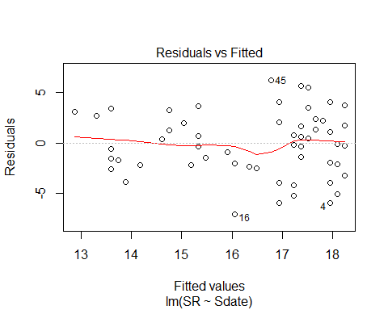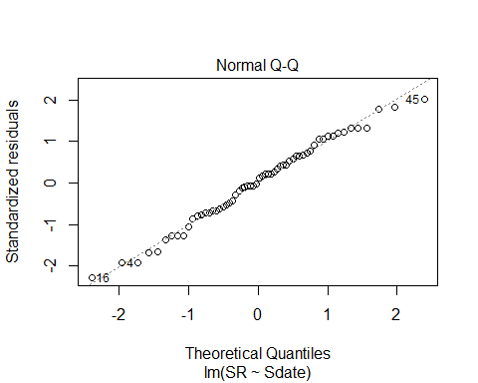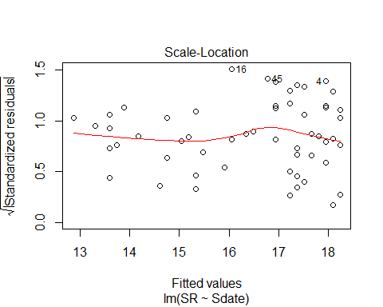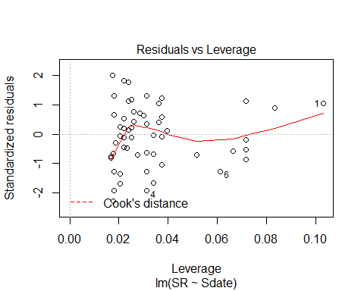

evaluation3<-lm(SR ~ Stime, methodSR1) #non-sig  
summary(evaluation3)

##   
## Call:  
## lm(formula = SR ~ Stime, data = methodSR1)  
##   
## Residuals:  
## Min 1Q Median 3Q Max   
## -7.4640 -2.7507 -0.0579 2.3835 6.9877   
##   
## Coefficients:  
## Estimate Std. Error t value Pr(>|t|)   
## (Intercept) 13.841924 3.056757 4.528 3.01e-05 ***  
## Stime 0.005866 0.006757 0.868 0.389   
## ---  
## Signif. codes: 0 '***' 0.001 '**' 0.01 '*' 0.05 '.' 0.1 ' ' 1  
##   
## Residual standard error: 3.488 on 58 degrees of freedom  
## Multiple R-squared: 0.01283, Adjusted R-squared: -0.004193   
## F-statistic: 0.7537 on 1 and 58 DF, p-value: 0.3889

confint(evaluation3, level=0.95)

## 2.5 % 97.5 %  
## (Intercept) 7.723160887 19.96068762  
## Stime -0.007659522 0.01939153

anova(evaluation3)

## Analysis of Variance Table  
##   
## Response: SR  
## Df Sum Sq Mean Sq F value Pr(>F)  
## Stime 1 9.17 9.1709 0.7537 0.3889  
## Residuals 58 705.76 12.1683

evaluation4<-lm(SR ~ Pdate, methodSR1) #non-sig  
summary(evaluation4)

##   
## Call:  
## lm(formula = SR ~ Pdate, data = methodSR1)  
##   
## Residuals:  
## Min 1Q Median 3Q Max   
## -6.0524 -1.5377 0.2123 2.1056 4.2123   
##   
## Coefficients:  
## Estimate Std. Error t value Pr(>|t|)  
## (Intercept) 5747.6507 5471.2258 1.051 0.302  
## Pdate -0.1323 0.1263 -1.048 0.304  
##   
## Residual standard error: 2.508 on 28 degrees of freedom  
## (30 observations deleted due to missingness)  
## Multiple R-squared: 0.03773, Adjusted R-squared: 0.003367   
## F-statistic: 1.098 on 1 and 28 DF, p-value: 0.3037

confint(evaluation4, level=0.95)

## 2.5 % 97.5 %  
## (Intercept) -5459.6472033 1.695495e+04  
## Pdate -0.3910672 1.263738e-01

anova(evaluation4)

## Analysis of Variance Table  
##   
## Response: SR  
## Df Sum Sq Mean Sq F value Pr(>F)  
## Pdate 1 6.904 6.9041 1.098 0.3037  
## Residuals 28 176.063 6.2879

evaluation5<-lm(SR ~ Pmin, methodSR1) #non-sig  
summary(evaluation5)

##   
## Call:  
## lm(formula = SR ~ Pmin, data = methodSR1)  
##   
## Residuals:  
## Min 1Q Median 3Q Max   
## -5.6238 -1.6442 0.3762 1.4580 4.4171   
##   
## Coefficients:  
## Estimate Std. Error t value Pr(>|t|)   
## (Intercept) 14.05095 2.55504 5.499 7.1e-06 ***  
## Pmin 0.04092 0.17650 0.232 0.818   
## ---  
## Signif. codes: 0 '***' 0.001 '**' 0.01 '*' 0.05 '.' 0.1 ' ' 1  
##   
## Residual standard error: 2.554 on 28 degrees of freedom  
## (30 observations deleted due to missingness)  
## Multiple R-squared: 0.001916, Adjusted R-squared: -0.03373   
## F-statistic: 0.05374 on 1 and 28 DF, p-value: 0.8184

confint(evaluation5, level=0.95)

## 2.5 % 97.5 %  
## (Intercept) 8.8171827 19.2847119  
## Pmin -0.3206202 0.4024543

anova(evaluation5)

## Analysis of Variance Table  
##   
## Response: SR  
## Df Sum Sq Mean Sq F value Pr(>F)  
## Pmin 1 0.351 0.3505 0.0537 0.8184  
## Residuals 28 182.616 6.5220

evaluation6<-lm(SR ~ Peffort, methodSR1) #non-sig  
summary(evaluation6)

##   
## Call:  
## lm(formula = SR ~ Peffort, data = methodSR1)  
##   
## Residuals:  
## Min 1Q Median 3Q Max   
## -5.5895 -1.6553 0.2789 1.5092 4.2789   
##   
## Coefficients:  
## Estimate Std. Error t value Pr(>|t|)   
## (Intercept) 14.8526 1.2841 11.567 3.53e-12 ***  
## Peffort -0.1316 0.7178 -0.183 0.856   
## ---  
## Signif. codes: 0 '***' 0.001 '**' 0.01 '*' 0.05 '.' 0.1 ' ' 1  
##   
## Residual standard error: 2.555 on 28 degrees of freedom  
## (30 observations deleted due to missingness)  
## Multiple R-squared: 0.001199, Adjusted R-squared: -0.03447   
## F-statistic: 0.0336 on 1 and 28 DF, p-value: 0.8559

confint(evaluation6, level=0.95)

## 2.5 % 97.5 %  
## (Intercept) 12.222323 17.482940  
## Peffort -1.601966 1.338808

anova(evaluation6)

## Analysis of Variance Table  
##   
## Response: SR  
## Df Sum Sq Mean Sq F value Pr(>F)  
## Peffort 1 0.219 0.2193 0.0336 0.8559  
## Residuals 28 182.747 6.5267

# Visit 2

methodSR2 <-read.csv("18_2by2_ACPC_SR.csv") #SR by count #2 each - Site Type SR  
#summary(methodSR2)  
str(methodSR2)

## 'data.frame': 60 obs. of 9 variables:  
## $ SiteName: Factor w/ 30 levels "Battlewood_1B_8",..: 1 2 3 4 5 6 7 8 9 10 ...  
## $ Type : Factor w/ 2 levels "AC","PC": 1 1 1 1 1 1 1 1 1 1 ...  
## $ SR : int 19 15 17 7 15 12 16 13 11 21 ...  
## $ Sdate : int 42 21 31 7 7 35 28 35 34 24 ...  
## $ Stime : int 444 443 556 355 508 410 424 478 556 464 ...  
## $ Pdate : int 43332 43328 43330 43326 43326 43330 43329 43332 43332 43328 ...  
## $ Pmin : int 12 11 14 13 12 13 12 12 12 13 ...  
## $ Peffort : int 2 1 3 2 1 2 2 2 2 1 ...  
## $ Year : Factor w/ 1 level "B": 1 1 1 1 1 1 1 1 1 1 ...

plot(methodSR2$SR ~ methodSR2$Type)

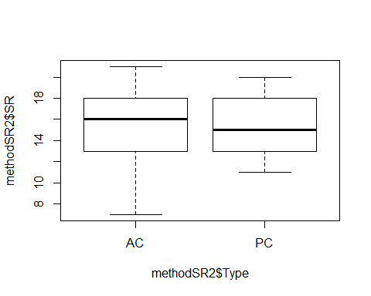

#plot(SR ~ Type, data=methodSR) #same as above

evaluation7<-lm(SR ~ Type, methodSR2) #non-sig  
summary(evaluation7)

##   
## Call:  
## lm(formula = SR ~ Type, data = methodSR2)  
##   
## Residuals:  
## Min 1Q Median 3Q Max   
## -8.3000 -2.1667 -0.1667 2.7000 5.7000   
##   
## Coefficients:  
## Estimate Std. Error t value Pr(>|t|)   
## (Intercept) 15.3000 0.5786 26.444 <2e-16 ***  
## TypePC -0.1333 0.8182 -0.163 0.871   
## ---  
## Signif. codes: 0 '***' 0.001 '**' 0.01 '*' 0.05 '.' 0.1 ' ' 1  
##   
## Residual standard error: 3.169 on 58 degrees of freedom  
## Multiple R-squared: 0.0004576, Adjusted R-squared: -0.01678   
## F-statistic: 0.02655 on 1 and 58 DF, p-value: 0.8711

confint(evaluation7, level=0.95)

## 2.5 % 97.5 %  
## (Intercept) 14.141853 16.458147  
## TypePC -1.771201 1.504534

anova(evaluation7)

## Analysis of Variance Table  
##   
## Response: SR  
## Df Sum Sq Mean Sq F value Pr(>F)  
## Type 1 0.27 0.2667 0.0266 0.8711  
## Residuals 58 582.47 10.0425

evaluation8<-lm(SR ~ Sdate, methodSR2) #non-sig  
summary(evaluation8)

##   
## Call:  
## lm(formula = SR ~ Sdate, data = methodSR2)  
##   
## Residuals:  
## Min 1Q Median 3Q Max   
## -7.5949 -2.1157 0.0001 2.7300 5.7493   
##   
## Coefficients:  
## Estimate Std. Error t value Pr(>|t|)   
## (Intercept) 14.32480 1.30616 10.967 9.08e-16 ***  
## Sdate 0.03858 0.05270 0.732 0.467   
## ---  
## Signif. codes: 0 '***' 0.001 '**' 0.01 '*' 0.05 '.' 0.1 ' ' 1  
##   
## Residual standard error: 3.155 on 58 degrees of freedom  
## Multiple R-squared: 0.009156, Adjusted R-squared: -0.007928   
## F-statistic: 0.536 on 1 and 58 DF, p-value: 0.4671

confint(evaluation8, level=0.95)

## 2.5 % 97.5 %  
## (Intercept) 11.71023625 16.9393586  
## Sdate -0.06690602 0.1440641

anova(evaluation8)

## Analysis of Variance Table  
##   
## Response: SR  
## Df Sum Sq Mean Sq F value Pr(>F)  
## Sdate 1 5.34 5.3355 0.536 0.4671  
## Residuals 58 577.40 9.9551

evaluation9<-lm(SR ~ Stime, methodSR2) #sig  
summary(evaluation9)

##   
## Call:  
## lm(formula = SR ~ Stime, data = methodSR2)  
##   
## Residuals:  
## Min 1Q Median 3Q Max   
## -6.7335 -1.7328 0.2862 1.8914 5.4427   
##   
## Coefficients:  
## Estimate Std. Error t value Pr(>|t|)   
## (Intercept) 7.510847 2.748974 2.732 0.00832 **  
## Stime 0.017529 0.006179 2.837 0.00626 **  
## ---  
## Signif. codes: 0 '***' 0.001 '**' 0.01 '*' 0.05 '.' 0.1 ' ' 1  
##   
## Residual standard error: 2.97 on 58 degrees of freedom  
## Multiple R-squared: 0.1219, Adjusted R-squared: 0.1067   
## F-statistic: 8.048 on 1 and 58 DF, p-value: 0.006264

confint(evaluation9, level=0.95)

## 2.5 % 97.5 %  
## (Intercept) 2.008176770 13.0135171  
## Stime 0.005160665 0.0298964

anova(evaluation9)

## Analysis of Variance Table  
##   
## Response: SR  
## Df Sum Sq Mean Sq F value Pr(>F)   
## Stime 1 71.01 71.009 8.0484 0.006264 **  
## Residuals 58 511.72 8.823   
## ---  
## Signif. codes: 0 '***' 0.001 '**' 0.01 '*' 0.05 '.' 0.1 ' ' 1

plot(SR ~ Stime, methodSR2)

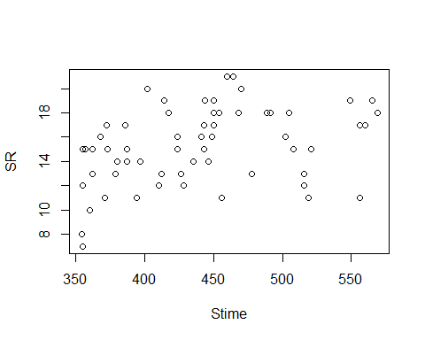

plot(evaluation9)

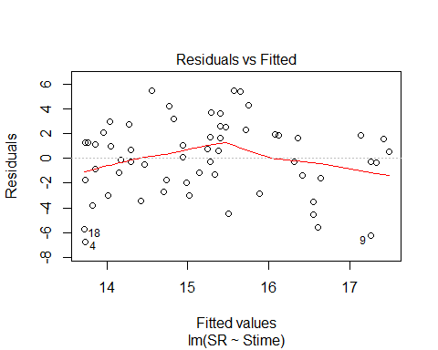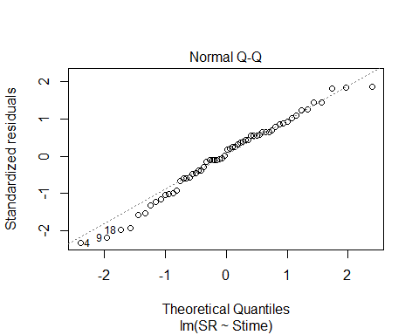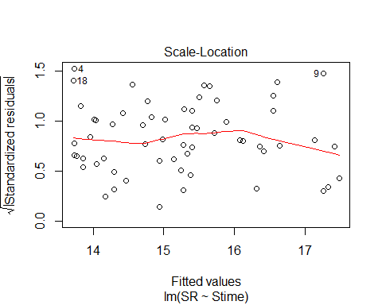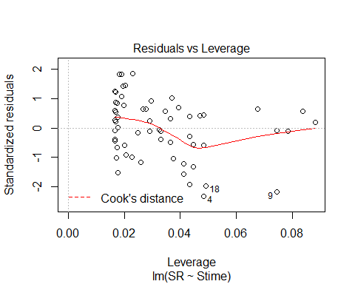

evaluation10<-lm(SR ~ Pdate, methodSR2) #non-sig  
summary(evaluation10)

##   
## Call:  
## lm(formula = SR ~ Pdate, data = methodSR2)  
##   
## Residuals:  
## Min 1Q Median 3Q Max   
## -8.4371 -1.9557 0.7171 2.6014 5.7686   
##   
## Coefficients:  
## Estimate Std. Error t value Pr(>|t|)  
## (Intercept) 2.244e+03 1.450e+04 0.155 0.878  
## Pdate -5.143e-02 3.347e-01 -0.154 0.879  
##   
## Residual standard error: 3.615 on 28 degrees of freedom  
## (30 observations deleted due to missingness)  
## Multiple R-squared: 0.0008424, Adjusted R-squared: -0.03484   
## F-statistic: 0.02361 on 1 and 28 DF, p-value: 0.879

confint(evaluation10, level=0.95)

## 2.5 % 97.5 %  
## (Intercept) -2.746445e+04 3.195172e+04  
## Pdate -7.370736e-01 6.342165e-01

anova(evaluation10)

## Analysis of Variance Table  
##   
## Response: SR  
## Df Sum Sq Mean Sq F value Pr(>F)  
## Pdate 1 0.31 0.3086 0.0236 0.879  
## Residuals 28 365.99 13.0711

evaluation11<-lm(SR ~ Pmin, methodSR2) #non-sig  
summary(evaluation11)

##   
## Call:  
## lm(formula = SR ~ Pmin, data = methodSR2)  
##   
## Residuals:  
## Min 1Q Median 3Q Max   
## -8.4461 -1.9526 0.7843 2.5539 5.5539   
##   
## Coefficients:  
## Estimate Std. Error t value Pr(>|t|)  
## (Intercept) 9.1166 7.7832 1.171 0.251  
## Pmin 0.4869 0.6107 0.797 0.432  
##   
## Residual standard error: 3.577 on 28 degrees of freedom  
## (30 observations deleted due to missingness)  
## Multiple R-squared: 0.0222, Adjusted R-squared: -0.01272   
## F-statistic: 0.6356 on 1 and 28 DF, p-value: 0.432

confint(evaluation11, level=0.95)

## 2.5 % 97.5 %  
## (Intercept) -6.8264478 25.059684  
## Pmin -0.7640531 1.737814

anova(evaluation11)

## Analysis of Variance Table  
##   
## Response: SR  
## Df Sum Sq Mean Sq F value Pr(>F)  
## Pmin 1 8.13 8.1309 0.6356 0.432  
## Residuals 28 358.17 12.7918

evaluation12<-lm(SR ~ Peffort, methodSR2) #non-sig  
summary(evaluation12)

##   
## Call:  
## lm(formula = SR ~ Peffort, data = methodSR2)  
##   
## Residuals:  
## Min 1Q Median 3Q Max   
## -8.2865 -2.0365 0.6882 2.6629 5.7135   
##   
## Coefficients:  
## Estimate Std. Error t value Pr(>|t|)   
## (Intercept) 15.38764 1.93596 7.948 1.17e-08 ***  
## Peffort -0.05056 1.04992 -0.048 0.962   
## ---  
## Signif. codes: 0 '***' 0.001 '**' 0.01 '*' 0.05 '.' 0.1 ' ' 1  
##   
## Residual standard error: 3.617 on 28 degrees of freedom  
## (30 observations deleted due to missingness)  
## Multiple R-squared: 8.282e-05, Adjusted R-squared: -0.03563   
## F-statistic: 0.002319 on 1 and 28 DF, p-value: 0.9619

confint(evaluation12, level=0.95)

## 2.5 % 97.5 %  
## (Intercept) 11.42200 19.353276  
## Peffort -2.20123 2.100106

anova(evaluation12)

## Analysis of Variance Table  
##   
## Response: SR  
## Df Sum Sq Mean Sq F value Pr(>F)  
## Peffort 1 0.03 0.0303 0.0023 0.9619  
## Residuals 28 366.27 13.0811

# Visit 3

#File read-in  
methodSR3 <-read.csv("18_3by3_ACPC_SR.csv") #SR by count #3 each - Site Type SR  
#summary(methodSR3)  
str(methodSR3)

## 'data.frame': 60 obs. of 9 variables:  
## $ SiteName: Factor w/ 30 levels "Battlewood_1B_8",..: 1 2 3 4 5 6 7 8 9 10 ...  
## $ Type : Factor w/ 2 levels "AC","PC": 1 1 1 1 1 1 1 1 1 1 ...  
## $ SR : int 18 15 13 13 9 14 14 15 15 15 ...  
## $ Sdate : int 41 22 33 5 8 35 28 34 36 23 ...  
## $ Stime : int 388 398 380 474 350 530 354 518 505 506 ...  
## $ Pdate : int 43338 43335 43338 43333 43333 43338 43336 43338 43338 43335 ...  
## $ Pmin : int 12 11 11 11 11 11 12 12 12 12 ...  
## $ Peffort : int 1 1 1 2 2 1 1 1 2 2 ...  
## $ Year : Factor w/ 1 level "B": 1 1 1 1 1 1 1 1 1 1 ...

plot(methodSR3$SR ~ methodSR3$Type) #

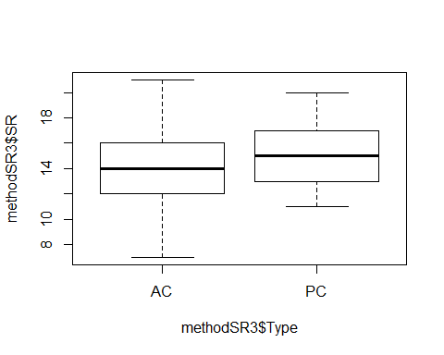

#plot(SR ~ Type, data=methodSR) #same as above

evaluation13<-lm(SR ~ Type, methodSR3) #non-sig  
summary(evaluation13)

##   
## Call:  
## lm(formula = SR ~ Type, data = methodSR3)  
##   
## Residuals:  
## Min 1Q Median 3Q Max   
## -7.0667 -2.1167 -0.0667 1.7333 6.9333   
##   
## Coefficients:  
## Estimate Std. Error t value Pr(>|t|)   
## (Intercept) 14.0667 0.5284 26.624 <2e-16 ***  
## TypePC 1.2000 0.7472 1.606 0.114   
## ---  
## Signif. codes: 0 '***' 0.001 '**' 0.01 '*' 0.05 '.' 0.1 ' ' 1  
##   
## Residual standard error: 2.894 on 58 degrees of freedom  
## Multiple R-squared: 0.04258, Adjusted R-squared: 0.02607   
## F-statistic: 2.579 on 1 and 58 DF, p-value: 0.1137

confint(evaluation13, level=0.95)

## 2.5 % 97.5 %  
## (Intercept) 13.0090529 15.124280  
## TypePC -0.2956918 2.695692

anova(evaluation13)

## Analysis of Variance Table  
##   
## Response: SR  
## Df Sum Sq Mean Sq F value Pr(>F)  
## Type 1 21.60 21.6000 2.5792 0.1137  
## Residuals 58 485.73 8.3747

evaluation14<-lm(SR ~ Sdate, methodSR3) #non-sig  
summary(evaluation14)

##   
## Call:  
## lm(formula = SR ~ Sdate, data = methodSR3)  
##   
## Residuals:  
## Min 1Q Median 3Q Max   
## -6.9959 -1.8663 0.0009 1.7214 6.4140   
##   
## Coefficients:  
## Estimate Std. Error t value Pr(>|t|)   
## (Intercept) 12.87480 1.22815 10.483 5.25e-15 ***  
## Sdate 0.05901 0.03852 1.532 0.131   
## ---  
## Signif. codes: 0 '***' 0.001 '**' 0.01 '*' 0.05 '.' 0.1 ' ' 1  
##   
## Residual standard error: 2.899 on 58 degrees of freedom  
## Multiple R-squared: 0.03889, Adjusted R-squared: 0.02232   
## F-statistic: 2.347 on 1 and 58 DF, p-value: 0.131

confint(evaluation14, level=0.95)

## 2.5 % 97.5 %  
## (Intercept) 10.41638692 15.3332160  
## Sdate -0.01809819 0.1361135

anova(evaluation14)

## Analysis of Variance Table  
##   
## Response: SR  
## Df Sum Sq Mean Sq F value Pr(>F)  
## Sdate 1 19.73 19.728 2.3466 0.131  
## Residuals 58 487.61 8.407

evaluation15<-lm(SR ~ Stime, methodSR3) #sig  
summary(evaluation15)

##   
## Call:  
## lm(formula = SR ~ Stime, data = methodSR3)  
##   
## Residuals:  
## Min 1Q Median 3Q Max   
## -6.4454 -1.2949 0.1177 1.5057 5.8216   
##   
## Coefficients:  
## Estimate Std. Error t value Pr(>|t|)   
## (Intercept) 6.78697 2.30296 2.947 0.00461 **  
## Stime 0.01824 0.00527 3.461 0.00102 **  
## ---  
## Signif. codes: 0 '***' 0.001 '**' 0.01 '*' 0.05 '.' 0.1 ' ' 1  
##   
## Residual standard error: 2.693 on 58 degrees of freedom  
## Multiple R-squared: 0.1712, Adjusted R-squared: 0.1569   
## F-statistic: 11.98 on 1 and 58 DF, p-value: 0.001016

confint(evaluation15, level=0.95)

## 2.5 % 97.5 %  
## (Intercept) 2.177087358 11.39684514  
## Stime 0.007692176 0.02879214

anova(evaluation15)

## Analysis of Variance Table  
##   
## Response: SR  
## Df Sum Sq Mean Sq F value Pr(>F)   
## Stime 1 86.85 86.851 11.98 0.001016 **  
## Residuals 58 420.48 7.250   
## ---  
## Signif. codes: 0 '***' 0.001 '**' 0.01 '*' 0.05 '.' 0.1 ' ' 1

plot(SR ~ Stime, methodSR3)

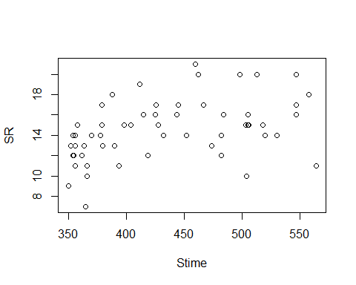

plot(evaluation15)

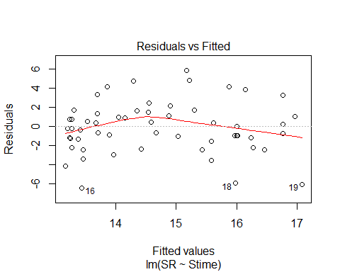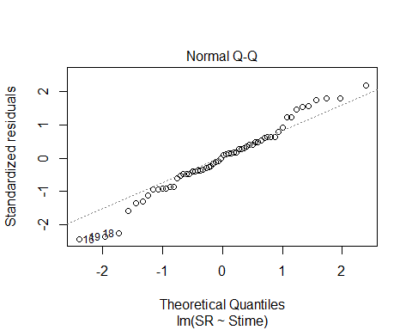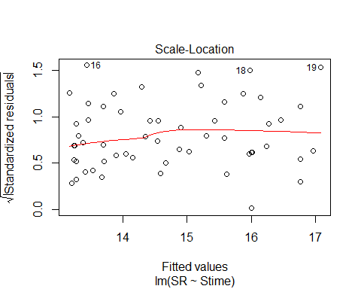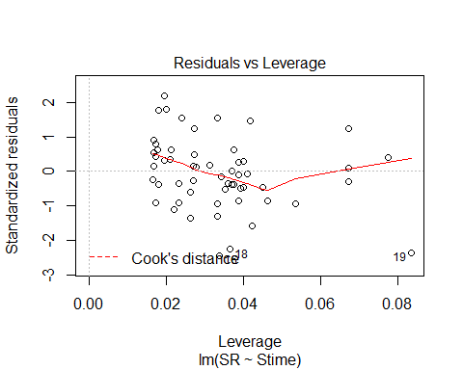

evaluation16<-lm(SR ~ Pdate, methodSR3) #non-sig  
summary(evaluation16)

##   
## Call:  
## lm(formula = SR ~ Pdate, data = methodSR3)  
##   
## Residuals:  
## Min 1Q Median 3Q Max   
## -6.838 -1.931 0.300 1.466 6.888   
##   
## Coefficients:  
## Estimate Std. Error t value Pr(>|t|)  
## (Intercept) -5944.5875 13312.5461 -0.447 0.659  
## Pdate 0.1375 0.3072 0.448 0.658  
##   
## Residual standard error: 3.173 on 28 degrees of freedom  
## (30 observations deleted due to missingness)  
## Multiple R-squared: 0.007104, Adjusted R-squared: -0.02836   
## F-statistic: 0.2003 on 1 and 28 DF, p-value: 0.6579

confint(evaluation16, level=0.95)

## 2.5 % 97.5 %  
## (Intercept) -3.321410e+04 2.132493e+04  
## Pdate -4.917626e-01 7.667626e-01

anova(evaluation16)

## Analysis of Variance Table  
##   
## Response: SR  
## Df Sum Sq Mean Sq F value Pr(>F)  
## Pdate 1 2.017 2.0167 0.2003 0.6579  
## Residuals 28 281.850 10.0661

evaluation17<-lm(SR ~ Pmin, methodSR3) #non-sig  
summary(evaluation17)

##   
## Call:  
## lm(formula = SR ~ Pmin, data = methodSR3)  
##   
## Residuals:  
## Min 1Q Median 3Q Max   
## -7.48 -1.92 0.52 1.52 6.52   
##   
## Coefficients:  
## Estimate Std. Error t value Pr(>|t|)  
## (Intercept) -0.4000 8.6964 -0.046 0.964  
## Pmin 1.2400 0.7439 1.667 0.107  
##   
## Residual standard error: 3.037 on 28 degrees of freedom  
## (30 observations deleted due to missingness)  
## Multiple R-squared: 0.09028, Adjusted R-squared: 0.05779   
## F-statistic: 2.779 on 1 and 28 DF, p-value: 0.1067

confint(evaluation17, level=0.95)

## 2.5 % 97.5 %  
## (Intercept) -18.2137744 17.413774  
## Pmin -0.2837883 2.763788

anova(evaluation17)

## Analysis of Variance Table  
##   
## Response: SR  
## Df Sum Sq Mean Sq F value Pr(>F)  
## Pmin 1 25.627 25.6267 2.7786 0.1067  
## Residuals 28 258.240 9.2229

evaluation18<-lm(SR ~ Peffort, methodSR3) #very close to sig (p.0591)  
summary(evaluation18)

##   
## Call:  
## lm(formula = SR ~ Peffort, data = methodSR3)  
##   
## Residuals:  
## Min 1Q Median 3Q Max   
## -6.1761 -1.8574 -0.0845 0.9155 5.9155   
##   
## Coefficients:  
## Estimate Std. Error t value Pr(>|t|)   
## (Intercept) 11.268 1.523 7.396 4.7e-08 ***  
## Peffort 1.909 0.970 1.968 0.0591 .   
## ---  
## Signif. codes: 0 '***' 0.001 '**' 0.01 '*' 0.05 '.' 0.1 ' ' 1  
##   
## Residual standard error: 2.984 on 28 degrees of freedom  
## (30 observations deleted due to missingness)  
## Multiple R-squared: 0.1215, Adjusted R-squared: 0.09009   
## F-statistic: 3.871 on 1 and 28 DF, p-value: 0.0591

confint(evaluation18, level=0.95)

## 2.5 % 97.5 %  
## (Intercept) 8.14705565 14.38816  
## Peffort -0.07844884 3.89535

anova(evaluation18)

## Analysis of Variance Table  
##   
## Response: SR  
## Df Sum Sq Mean Sq F value Pr(>F)   
## Peffort 1 34.479 34.479 3.8712 0.0591 .  
## Residuals 28 249.387 8.907   
## ---  
## Signif. codes: 0 '***' 0.001 '**' 0.01 '*' 0.05 '.' 0.1 ' ' 1

plot(SR ~ Peffort, methodSR3)

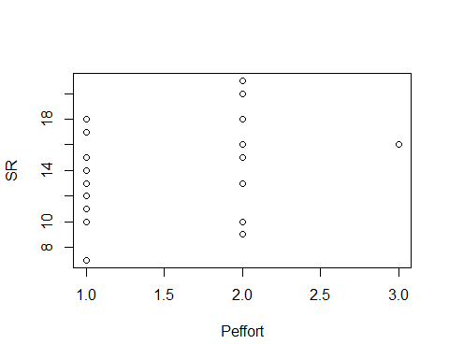

plot(evaluation18)

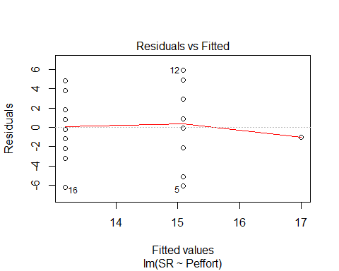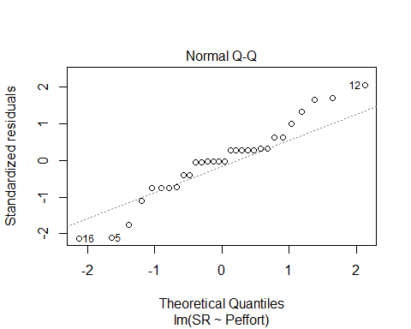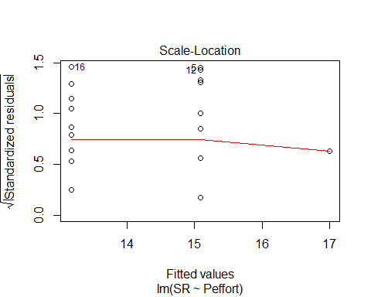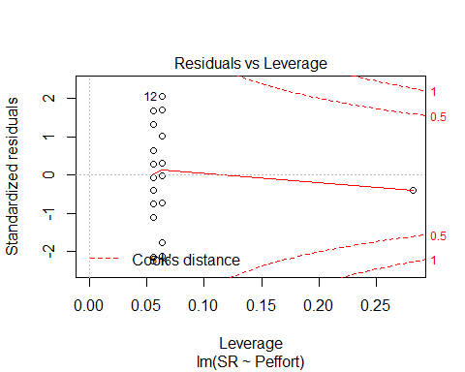

# 3 visits pooled 2018

#File read-in  
# UNKNS removed  
methodOSR <-read.csv("18_all3_ACPC_SR.csv") #SR by 3 counts pooled SR with unkns extracted  
#summary(methodOSR)  
str(methodOSR)

## 'data.frame': 60 obs. of 4 variables:  
## $ SiteName: Factor w/ 30 levels "Battlewood_1B_8",..: 1 2 3 4 5 6 7 8 9 10 ...  
## $ Type : Factor w/ 2 levels "AC","PC": 1 1 1 1 1 1 1 1 1 1 ...  
## $ SR : int 26 19 23 18 21 21 23 22 20 29 ...  
## $ Year : Factor w/ 1 level "B": 1 1 1 1 1 1 1 1 1 1 ...

plot(methodOSR$SR ~ methodOSR$Type)

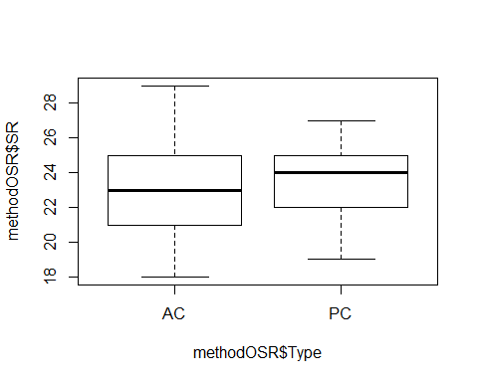

tapply(methodOSR$SR, methodOSR$Type,mean)

## AC PC   
## 22.83333 23.66667

evaluationOSR<-lm(SR ~ Type, methodOSR) #non-sig  
summary(evaluationOSR)

##   
## Call:  
## lm(formula = SR ~ Type, data = methodOSR)  
##   
## Residuals:  
## Min 1Q Median 3Q Max   
## -4.8333 -1.8333 0.1667 1.5417 6.1667   
##   
## Coefficients:  
## Estimate Std. Error t value Pr(>|t|)   
## (Intercept) 22.8333 0.4490 50.850 <2e-16 ***  
## TypePC 0.8333 0.6350 1.312 0.195   
## ---  
## Signif. codes: 0 '***' 0.001 '**' 0.01 '*' 0.05 '.' 0.1 ' ' 1  
##   
## Residual standard error: 2.459 on 58 degrees of freedom  
## Multiple R-squared: 0.02884, Adjusted R-squared: 0.01209   
## F-statistic: 1.722 on 1 and 58 DF, p-value: 0.1946

confint(evaluationOSR, level=0.95)

## 2.5 % 97.5 %  
## (Intercept) 21.9345012 23.732165  
## TypePC -0.4378072 2.104474

anova(evaluationOSR)

## Analysis of Variance Table  
##   
## Response: SR  
## Df Sum Sq Mean Sq F value Pr(>F)  
## Type 1 10.42 10.4167 1.7221 0.1946  
## Residuals 58 350.83 6.0489

#### 2017+2018 together

# don’t forget to do min, max, mean, etc. and test if significant effect of years - do separately if so. pool if not.

#File read-in  
# UNKNS removed  
methodOOSR <-read.csv("17_18_all3_ACPC_SR.csv") #SR by 3 counts pooled SR with unkns extracted for BOTH years - Year column A or B  
summary(methodOOSR)

## SiteName Type SR Year   
## Blease_3B_6 : 4 AC:59 Min. :15.00 A:58   
## Blease_3B_9 : 4 PC:59 1st Qu.:21.25 B:60   
## Bryson_2B_9 : 4 Median :23.00   
## Burnett_1B_5 : 4 Mean :23.56   
## Creswell_0B_8 : 4 3rd Qu.:25.00   
## Creswell_2B_10: 4 Max. :34.00   
## (Other) :94

str(methodOOSR)

## 'data.frame': 118 obs. of 4 variables:  
## $ SiteName: Factor w/ 37 levels "Abercrombie_0B_E_AB",..: 4 5 6 8 9 15 16 17 18 19 ...  
## $ Type : Factor w/ 2 levels "AC","PC": 1 1 1 1 1 1 1 1 1 1 ...  
## $ SR : int 23 22 18 24 23 25 23 26 24 21 ...  
## $ Year : Factor w/ 2 levels "A","B": 1 1 1 1 1 1 1 1 1 1 ...

plot(methodOOSR$SR ~ methodOOSR$Type)

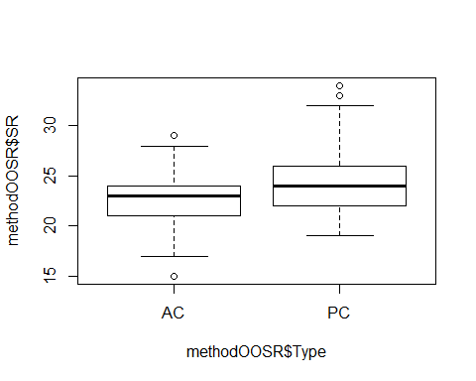

summary(methodOOSR$SR)

## Min. 1st Qu. Median Mean 3rd Qu. Max.   
## 15.00 21.25 23.00 23.56 25.00 34.00

#library(psych)  
mean(methodOOSR$SR)

## [1] 23.55932

#tapply(methodOOSR$SR, methodOOSR$Type)

evaluationOOSR<-lm(SR ~ Type, methodOOSR) #sig - PC +   
summary(evaluationOOSR)

##   
## Call:  
## lm(formula = SR ~ Type, data = methodOOSR)  
##   
## Residuals:  
## Min 1Q Median 3Q Max   
## -7.6949 -1.6949 -0.0593 1.5763 9.5763   
##   
## Coefficients:  
## Estimate Std. Error t value Pr(>|t|)   
## (Intercept) 22.6949 0.4014 56.534 < 2e-16 ***  
## TypePC 1.7288 0.5677 3.045 0.00288 **   
## ---  
## Signif. codes: 0 '***' 0.001 '**' 0.01 '*' 0.05 '.' 0.1 ' ' 1  
##   
## Residual standard error: 3.083 on 116 degrees of freedom  
## Multiple R-squared: 0.07402, Adjusted R-squared: 0.06604   
## F-statistic: 9.273 on 1 and 116 DF, p-value: 0.002878

confint(evaluationOOSR, level=0.95)

## 2.5 % 97.5 %  
## (Intercept) 21.8998211 23.490009  
## TypePC 0.6043807 2.853246

anova(evaluationOOSR)

## Analysis of Variance Table  
##   
## Response: SR  
## Df Sum Sq Mean Sq F value Pr(>F)   
## Type 1 88.17 88.169 9.2733 0.002878 **  
## Residuals 116 1102.92 9.508   
## ---  
## Signif. codes: 0 '***' 0.001 '**' 0.01 '*' 0.05 '.' 0.1 ' ' 1

Evaluated effect of year on SR results and no significant difference, so it is ok to pool for the rest of the Ch 2 results!

yearevalOOSR<-lm(SR ~ Year, methodOOSR)  
summary(yearevalOOSR)

##   
## Call:  
## lm(formula = SR ~ Year, data = methodOOSR)  
##   
## Residuals:  
## Min 1Q Median 3Q Max   
## -8.879 -2.157 -0.250 1.750 10.121   
##   
## Coefficients:  
## Estimate Std. Error t value Pr(>|t|)   
## (Intercept) 23.8793 0.4187 57.034 <2e-16 ***  
## YearB -0.6293 0.5872 -1.072 0.286   
## ---  
## Signif. codes: 0 '***' 0.001 '**' 0.01 '*' 0.05 '.' 0.1 ' ' 1  
##   
## Residual standard error: 3.189 on 116 degrees of freedom  
## Multiple R-squared: 0.009806, Adjusted R-squared: 0.00127   
## F-statistic: 1.149 on 1 and 116 DF, p-value: 0.286

confint(yearevalOOSR, level=0.95)

## 2.5 % 97.5 %  
## (Intercept) 23.050050 24.7085709  
## YearB -1.792248 0.5336272

anova(yearevalOOSR)

## Analysis of Variance Table  
##   
## Response: SR  
## Df Sum Sq Mean Sq F value Pr(>F)  
## Year 1 11.68 11.680 1.1487 0.286  
## Residuals 116 1179.41 10.167

plot(yearevalOOSR)

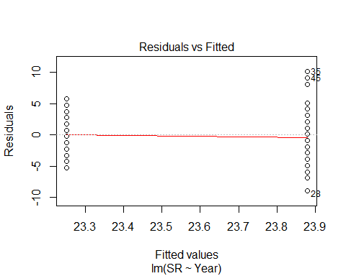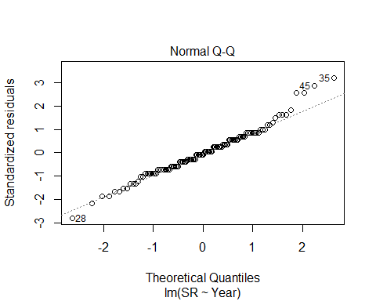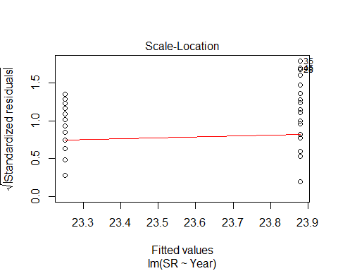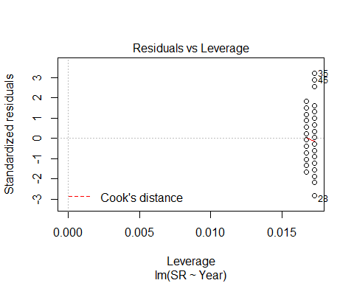

No sig interaction w/ both (Year * Type nor Year + Type)

yearintevalOOSR<-lm(SR ~ Year * Type, methodOOSR)  
summary(yearintevalOOSR)

##   
## Call:  
## lm(formula = SR ~ Year * Type, data = methodOOSR)  
##   
## Residuals:  
## Min 1Q Median 3Q Max   
## -7.5517 -2.1135 0.1667 1.7069 8.7931   
##   
## Coefficients:  
## Estimate Std. Error t value Pr(>|t|)   
## (Intercept) 22.5517 0.5680 39.701 < 2e-16 ***  
## YearB 0.2816 0.7966 0.354 0.72436   
## TypePC 2.6552 0.8033 3.305 0.00127 **   
## YearB:TypePC -1.8218 1.1266 -1.617 0.10861   
## ---  
## Signif. codes: 0 '***' 0.001 '**' 0.01 '*' 0.05 '.' 0.1 ' ' 1  
##   
## Residual standard error: 3.059 on 114 degrees of freedom  
## Multiple R-squared: 0.1044, Adjusted R-squared: 0.08081   
## F-statistic: 4.429 on 3 and 114 DF, p-value: 0.005532

confint(yearintevalOOSR, level=0.95)

## 2.5 % 97.5 %  
## (Intercept) 21.426431 23.6770171  
## YearB -1.296478 1.8596964  
## TypePC 1.063768 4.2465770  
## YearB:TypePC -4.053591 0.4099132

anova(yearintevalOOSR)

## Analysis of Variance Table  
##   
## Response: SR  
## Df Sum Sq Mean Sq F value Pr(>F)   
## Year 1 11.68 11.680 1.2481 0.26626   
## Type 1 88.17 88.169 9.4223 0.00268 **  
## Year:Type 1 24.47 24.471 2.6151 0.10861   
## Residuals 114 1066.76 9.358   
## ---  
## Signif. codes: 0 '***' 0.001 '**' 0.01 '*' 0.05 '.' 0.1 ' ' 1

## back to individual visits, but years pooled together (17+18):

# visit 1 _ method only

methodYSR1 <-read.csv("17_18_1by1_ACPC_SR.csv") #SR by count #1 each - Site Type SR  
#summary(methodYSR1)  
str(methodYSR1)

## 'data.frame': 118 obs. of 9 variables:  
## $ SiteName: Factor w/ 37 levels "Abercrombie_0B_E_AB",..: 4 5 6 8 9 15 16 17 18 19 ...  
## $ Type : Factor w/ 2 levels "AC","PC": 1 1 1 1 1 1 1 1 1 1 ...  
## $ SR : int 15 14 11 10 12 16 13 17 14 11 ...  
## $ Sdate : int 3 16 31 33 23 24 30 27 10 22 ...  
## $ Stime : int 570 403 497 380 503 382 479 481 580 409 ...  
## $ Pdate : int 43181 43181 43186 43195 43196 43182 43188 43188 43188 43188 ...  
## $ Pmin : int 26 23 17 20 32 31 18 20 25 18 ...  
## $ Peffort : int 3 2 1 2 3 3 2 2 4 3 ...  
## $ Year : Factor w/ 2 levels "A","B": 1 1 1 1 1 1 1 1 1 1 ...

plot(methodYSR1$SR ~ methodYSR1$Type)

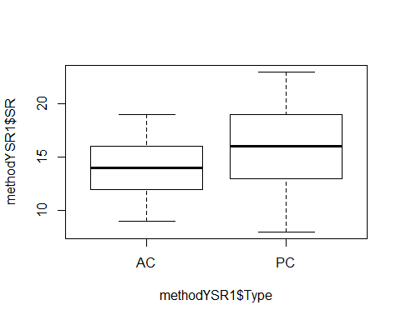

evaluationYVM1<-lm(SR ~ Type, methodYSR1) #sig! p.0002  
summary(evaluationYVM1)

##   
## Call:  
## lm(formula = SR ~ Type, data = methodYSR1)  
##   
## Residuals:  
## Min 1Q Median 3Q Max   
## -8.5085 -2.2373 -0.2373 2.4915 6.4915   
##   
## Coefficients:  
## Estimate Std. Error t value Pr(>|t|)   
## (Intercept) 14.2373 0.4179 34.066 < 2e-16 ***  
## TypePC 2.2712 0.5910 3.843 0.000199 ***  
## ---  
## Signif. codes: 0 '***' 0.001 '**' 0.01 '*' 0.05 '.' 0.1 ' ' 1  
##   
## Residual standard error: 3.21 on 116 degrees of freedom  
## Multiple R-squared: 0.1129, Adjusted R-squared: 0.1053   
## F-statistic: 14.77 on 1 and 116 DF, p-value: 0.0001991

confint(evaluationYVM1, level=0.95)

## 2.5 % 97.5 %  
## (Intercept) 13.409521 15.065056  
## TypePC 1.100546 3.441827

anova(evaluationYVM1)

## Analysis of Variance Table  
##   
## Response: SR  
## Df Sum Sq Mean Sq F value Pr(>F)   
## Type 1 152.17 152.169 14.766 0.0001991 ***  
## Residuals 116 1195.42 10.305   
## ---  
## Signif. codes: 0 '***' 0.001 '**' 0.01 '*' 0.05 '.' 0.1 ' ' 1

plot(evaluationYVM1)

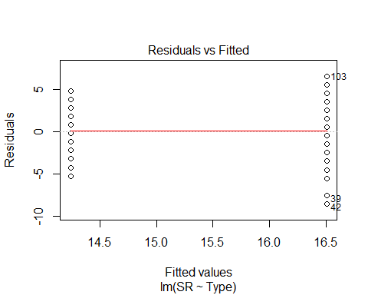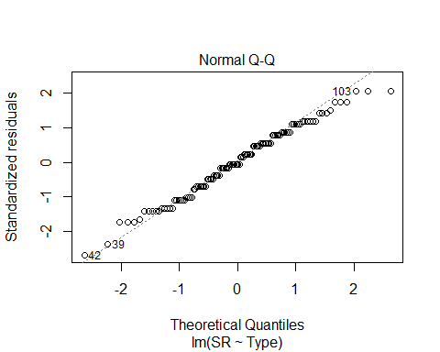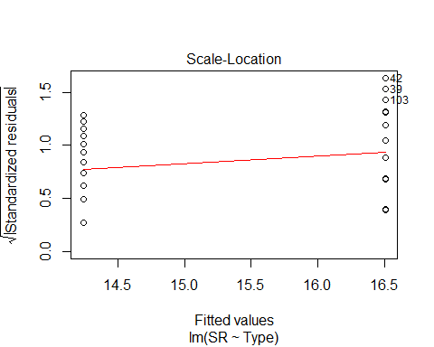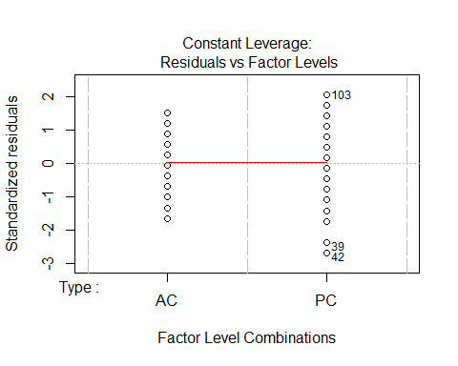

# visit 2 _ method only

methodYSR2 <-read.csv("17_18_2by2_ACPC_SR.csv") #SR by count #2 each - Site Type SR  
#summary(methodYSR2)  
str(methodYSR2)

## 'data.frame': 118 obs. of 9 variables:  
## $ SiteName: Factor w/ 37 levels "Abercrombie_0B_E_AB",..: 4 5 6 8 9 15 16 17 18 19 ...  
## $ Type : Factor w/ 2 levels "AC","PC": 1 1 1 1 1 1 1 1 1 1 ...  
## $ SR : int 17 15 12 9 9 16 13 11 17 13 ...  
## $ Sdate : int 2 17 28 36 22 25 35 28 9 22 ...  
## $ Stime : int 426 353 553 355 354 558 386 425 521 514 ...  
## $ Pdate : int 43201 43201 43203 43209 43210 43202 43205 43205 43206 43205 ...  
## $ Pmin : int 39 25 37 14 15 15 18 22 15 21 ...  
## $ Peffort : int 4 3 7 1 1 2 2 2 2 2 ...  
## $ Year : Factor w/ 2 levels "A","B": 1 1 1 1 1 1 1 1 1 1 ...

plot(methodYSR2$SR ~ methodYSR2$Type)

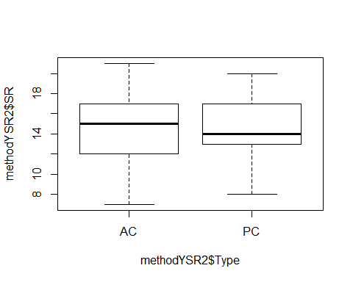

#plot(SR ~ Type, data=methodSR) #same as above

evaluationYVM2<-lm(SR ~ Type, methodYSR2) #non-sig  
summary(evaluationYVM2)

##   
## Call:  
## lm(formula = SR ~ Type, data = methodYSR2)  
##   
## Residuals:  
## Min 1Q Median 3Q Max   
## -7.3559 -2.3559 0.0339 2.6441 6.6441   
##   
## Coefficients:  
## Estimate Std. Error t value Pr(>|t|)   
## (Intercept) 14.3559 0.4078 35.207 <2e-16 ***  
## TypePC 0.2203 0.5767 0.382 0.703   
## ---  
## Signif. codes: 0 '***' 0.001 '**' 0.01 '*' 0.05 '.' 0.1 ' ' 1  
##   
## Residual standard error: 3.132 on 116 degrees of freedom  
## Multiple R-squared: 0.001257, Adjusted R-squared: -0.007353   
## F-statistic: 0.146 on 1 and 116 DF, p-value: 0.7031

confint(evaluationYVM2, level=0.95)

## 2.5 % 97.5 %  
## (Intercept) 13.5483148 15.163550  
## TypePC -0.9218045 1.362482

anova(evaluationYVM2)

## Analysis of Variance Table  
##   
## Response: SR  
## Df Sum Sq Mean Sq F value Pr(>F)  
## Type 1 1.43 1.4322 0.146 0.7031  
## Residuals 116 1137.93 9.8098

# visit 3 _ method only

methodYSR3 <-read.csv("17_18_3by3_ACPC_SR.csv") #SR by count #3 each - Site Type SR  
#summary(methodYSR3)  
str(methodYSR3)

## 'data.frame': 118 obs. of 9 variables:  
## $ SiteName: Factor w/ 37 levels "Abercrombie_0B_E_AB",..: 4 5 6 8 9 15 16 17 18 19 ...  
## $ Type : Factor w/ 2 levels "AC","PC": 1 1 1 1 1 1 1 1 1 1 ...  
## $ SR : int 10 16 11 16 16 16 14 14 15 14 ...  
## $ Sdate : int 15 18 47 33 22 33 34 29 10 20 ...  
## $ Stime : int 363 500 380 513 559 507 526 359 395 566 ...  
## $ Pdate : int 43214 43214 43216 43219 43220 43215 43216 43216 43217 43216 ...  
## $ Pmin : int 18 15 14 27 12 26 14 19 24 19 ...  
## $ Peffort : int 1 2 2 7 2 8 2 4 5 5 ...  
## $ Year : Factor w/ 2 levels "A","B": 1 1 1 1 1 1 1 1 1 1 ...

plot(methodYSR3$SR ~ methodYSR3$Type)

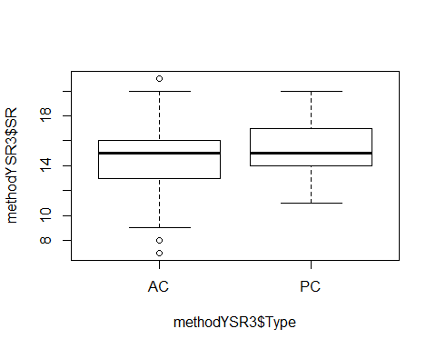

#plot(SR ~ Type, data=methodSR) #same as above

evaluationYVM3<-lm(SR ~ Type, methodYSR3) #marginally sig  
summary(evaluationYVM3)

##   
## Call:  
## lm(formula = SR ~ Type, data = methodYSR3)  
##   
## Residuals:  
## Min 1Q Median 3Q Max   
## -7.2712 -1.2712 -0.2203 1.7288 6.7288   
##   
## Coefficients:  
## Estimate Std. Error t value Pr(>|t|)   
## (Intercept) 14.2712 0.3440 41.488 <2e-16 ***  
## TypePC 0.9492 0.4865 1.951 0.0535 .   
## ---  
## Signif. codes: 0 '***' 0.001 '**' 0.01 '*' 0.05 '.' 0.1 ' ' 1  
##   
## Residual standard error: 2.642 on 116 degrees of freedom  
## Multiple R-squared: 0.03178, Adjusted R-squared: 0.02343   
## F-statistic: 3.807 on 1 and 116 DF, p-value: 0.05345

confint(evaluationYVM3, level=0.95)

## 2.5 % 97.5 %  
## (Intercept) 13.58989105 14.95248  
## TypePC -0.01434464 1.91265

anova(evaluationYVM3)

## Analysis of Variance Table  
##   
## Response: SR  
## Df Sum Sq Mean Sq F value Pr(>F)   
## Type 1 26.58 26.576 3.8069 0.05345 .  
## Residuals 116 809.80 6.981   
## ---  
## Signif. codes: 0 '***' 0.001 '**' 0.01 '*' 0.05 '.' 0.1 ' ' 1

#### 2017+2018 COMBINED, SOLO VISITS - ALL VARIABLES

# visit 1 - all variables

#File read-in  
# updated 9/12 - unknowns REMOVED (in both AC + PC)  
methodYSR1 <-read.csv("17_18_1by1_ACPC_SR.csv") #SR by count #1 each - Site Type SR  
#summary(methodYSR1)  
str(methodYSR1)

## 'data.frame': 118 obs. of 9 variables:  
## $ SiteName: Factor w/ 37 levels "Abercrombie_0B_E_AB",..: 4 5 6 8 9 15 16 17 18 19 ...  
## $ Type : Factor w/ 2 levels "AC","PC": 1 1 1 1 1 1 1 1 1 1 ...  
## $ SR : int 15 14 11 10 12 16 13 17 14 11 ...  
## $ Sdate : int 3 16 31 33 23 24 30 27 10 22 ...  
## $ Stime : int 570 403 497 380 503 382 479 481 580 409 ...  
## $ Pdate : int 43181 43181 43186 43195 43196 43182 43188 43188 43188 43188 ...  
## $ Pmin : int 26 23 17 20 32 31 18 20 25 18 ...  
## $ Peffort : int 3 2 1 2 3 3 2 2 4 3 ...  
## $ Year : Factor w/ 2 levels "A","B": 1 1 1 1 1 1 1 1 1 1 ...

#plot(methodYSR1$SR ~ methodYSR1$Type) #same as below  
plot(SR ~ Type, data=methodYSR1)

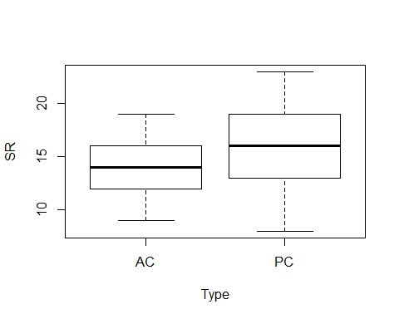

plot(SR ~ Sdate, data=methodYSR1)

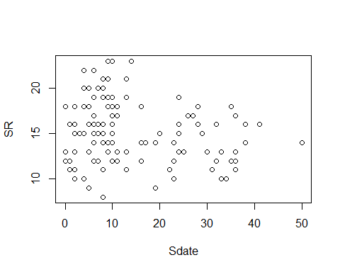

plot(SR ~ Stime, data=methodYSR1)

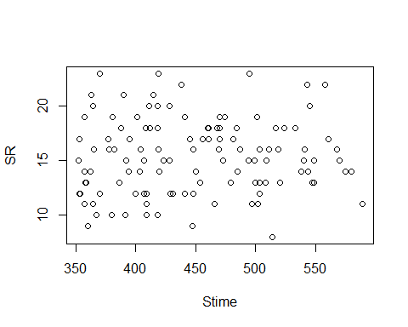

plot(SR ~ Pdate, data=methodYSR1)

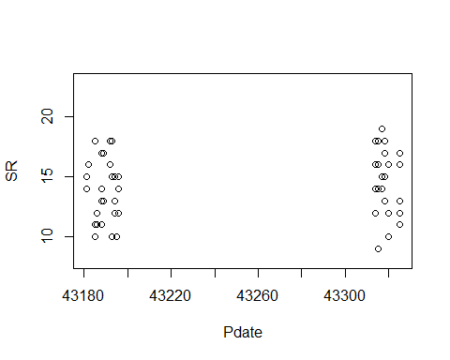

plot(SR ~ Pmin, data=methodYSR1) #?

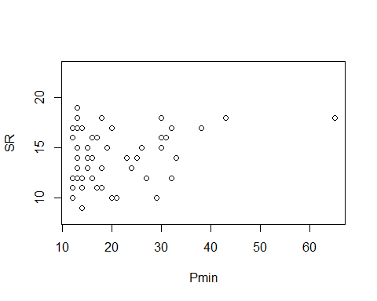

plot(SR ~ Peffort, data=methodYSR1)

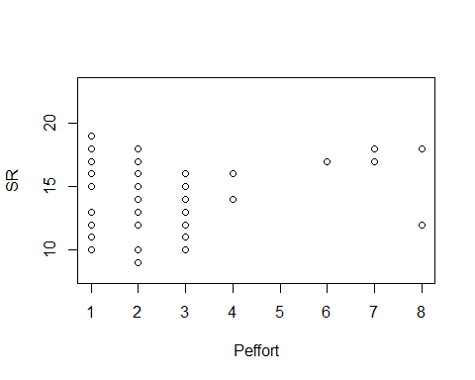

evaluationYV1<-lm(SR ~ Type, methodYSR1) #sig  
summary(evaluationYV1)

##   
## Call:  
## lm(formula = SR ~ Type, data = methodYSR1)  
##   
## Residuals:  
## Min 1Q Median 3Q Max   
## -8.5085 -2.2373 -0.2373 2.4915 6.4915   
##   
## Coefficients:  
## Estimate Std. Error t value Pr(>|t|)   
## (Intercept) 14.2373 0.4179 34.066 < 2e-16 ***  
## TypePC 2.2712 0.5910 3.843 0.000199 ***  
## ---  
## Signif. codes: 0 '***' 0.001 '**' 0.01 '*' 0.05 '.' 0.1 ' ' 1  
##   
## Residual standard error: 3.21 on 116 degrees of freedom  
## Multiple R-squared: 0.1129, Adjusted R-squared: 0.1053   
## F-statistic: 14.77 on 1 and 116 DF, p-value: 0.0001991

confint(evaluationYV1, level=0.95)

## 2.5 % 97.5 %  
## (Intercept) 13.409521 15.065056  
## TypePC 1.100546 3.441827

anova(evaluationYV1)

## Analysis of Variance Table  
##   
## Response: SR  
## Df Sum Sq Mean Sq F value Pr(>F)   
## Type 1 152.17 152.169 14.766 0.0001991 ***  
## Residuals 116 1195.42 10.305   
## ---  
## Signif. codes: 0 '***' 0.001 '**' 0.01 '*' 0.05 '.' 0.1 ' ' 1

plot(evaluationYV1)



evaluationYV2<-lm(SR ~ Sdate, methodYSR1) #sig  
summary(evaluationYV2)

##   
## Call:  
## lm(formula = SR ~ Sdate, data = methodYSR1)  
##   
## Residuals:  
## Min 1Q Median 3Q Max   
## -7.7237 -2.4502 -0.0458 2.3216 7.5985   
##   
## Coefficients:  
## Estimate Std. Error t value Pr(>|t|)   
## (Intercept) 16.15316 0.49306 32.761 <2e-16 ***  
## Sdate -0.05369 0.02647 -2.028 0.0449 *   
## ---  
## Signif. codes: 0 '***' 0.001 '**' 0.01 '*' 0.05 '.' 0.1 ' ' 1  
##   
## Residual standard error: 3.35 on 116 degrees of freedom  
## Multiple R-squared: 0.03424, Adjusted R-squared: 0.02592   
## F-statistic: 4.113 on 1 and 116 DF, p-value: 0.04485

confint(evaluationYV2, level=0.95)

## 2.5 % 97.5 %  
## (Intercept) 15.1765827 17.129736967  
## Sdate -0.1061192 -0.001254348

anova(evaluationYV2)

## Analysis of Variance Table  
##   
## Response: SR  
## Df Sum Sq Mean Sq F value Pr(>F)   
## Sdate 1 46.14 46.143 4.1128 0.04485 *  
## Residuals 116 1301.45 11.219   
## ---  
## Signif. codes: 0 '***' 0.001 '**' 0.01 '*' 0.05 '.' 0.1 ' ' 1

plot(SR ~ Sdate, methodYSR1)



plot(evaluationYV2)

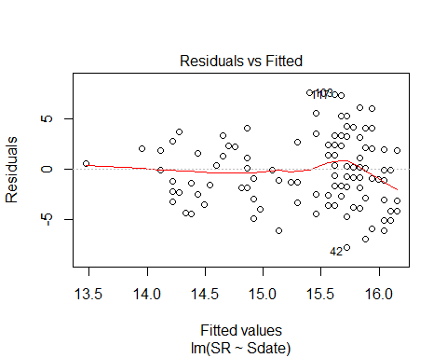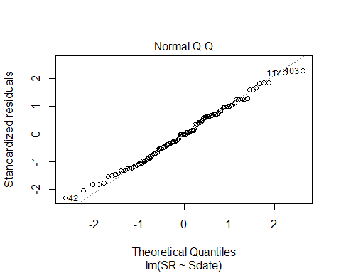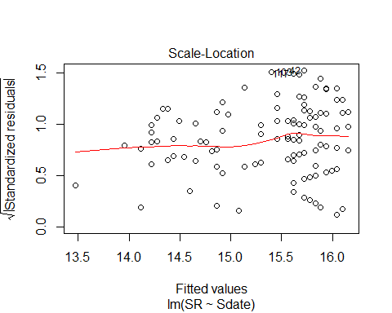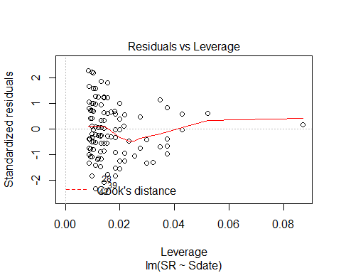

evaluationYV3<-lm(SR ~ Stime, methodYSR1) #non-sig  
summary(evaluationYV3)

##   
## Call:  
## lm(formula = SR ~ Stime, data = methodYSR1)  
##   
## Residuals:  
## Min 1Q Median 3Q Max   
## -7.5462 -2.5540 -0.2474 2.5106 7.8296   
##   
## Coefficients:  
## Estimate Std. Error t value Pr(>|t|)   
## (Intercept) 14.204638 2.181645 6.511 1.99e-09 ***  
## Stime 0.002610 0.004824 0.541 0.589   
## ---  
## Signif. codes: 0 '***' 0.001 '**' 0.01 '*' 0.05 '.' 0.1 ' ' 1  
##   
## Residual standard error: 3.404 on 116 degrees of freedom  
## Multiple R-squared: 0.002518, Adjusted R-squared: -0.006081   
## F-statistic: 0.2928 on 1 and 116 DF, p-value: 0.5895

confint(evaluationYV3, level=0.95)

## 2.5 % 97.5 %  
## (Intercept) 9.883615468 18.52565972  
## Stime -0.006943735 0.01216385

anova(evaluationYV3)

## Analysis of Variance Table  
##   
## Response: SR  
## Df Sum Sq Mean Sq F value Pr(>F)  
## Stime 1 3.39 3.3928 0.2928 0.5895  
## Residuals 116 1344.20 11.5879

evaluationYV4<-lm(SR ~ Pdate, methodYSR1) #non-sig  
summary(evaluationYV4)

##   
## Call:  
## lm(formula = SR ~ Pdate, data = methodYSR1)  
##   
## Residuals:  
## Min 1Q Median 3Q Max   
## -5.6001 -1.8778 0.2065 1.7731 4.3879   
##   
## Coefficients:  
## Estimate Std. Error t value Pr(>|t|)  
## (Intercept) -2.461e+02 2.236e+02 -1.101 0.276  
## Pdate 6.019e-03 5.170e-03 1.164 0.249  
##   
## Residual standard error: 2.567 on 57 degrees of freedom  
## (59 observations deleted due to missingness)  
## Multiple R-squared: 0.02323, Adjusted R-squared: 0.006098   
## F-statistic: 1.356 on 1 and 57 DF, p-value: 0.2491

confint(evaluationYV4, level=0.95)

## 2.5 % 97.5 %  
## (Intercept) -6.938916e+02 201.63351523  
## Pdate -4.332375e-03 0.01637112

anova(evaluationYV4)

## Analysis of Variance Table  
##   
## Response: SR  
## Df Sum Sq Mean Sq F value Pr(>F)  
## Pdate 1 8.94 8.9375 1.3558 0.2491  
## Residuals 57 375.74 6.5919

evaluationYV5<-lm(SR ~ Pmin, methodYSR1) #close to but non-sig  
summary(evaluationYV5)

##   
## Call:  
## lm(formula = SR ~ Pmin, data = methodYSR1)  
##   
## Residuals:  
## Min 1Q Median 3Q Max   
## -4.8637 -1.8313 0.0991 1.9556 5.2011   
##   
## Coefficients:  
## Estimate Std. Error t value Pr(>|t|)   
## (Intercept) 12.95617 0.75366 17.191 <2e-16 ***  
## Pmin 0.06483 0.03433 1.888 0.0641 .   
## ---  
## Signif. codes: 0 '***' 0.001 '**' 0.01 '*' 0.05 '.' 0.1 ' ' 1  
##   
## Residual standard error: 2.52 on 57 degrees of freedom  
## (59 observations deleted due to missingness)  
## Multiple R-squared: 0.05887, Adjusted R-squared: 0.04236   
## F-statistic: 3.565 on 1 and 57 DF, p-value: 0.06409

confint(evaluationYV5, level=0.95)

## 2.5 % 97.5 %  
## (Intercept) 11.446996148 14.4653373  
## Pmin -0.003922906 0.1335733

anova(evaluationYV5)

## Analysis of Variance Table  
##   
## Response: SR  
## Df Sum Sq Mean Sq F value Pr(>F)   
## Pmin 1 22.64 22.6449 3.5653 0.06409 .  
## Residuals 57 362.03 6.3515   
## ---  
## Signif. codes: 0 '***' 0.001 '**' 0.01 '*' 0.05 '.' 0.1 ' ' 1

evaluationYV6<-lm(SR ~ Peffort, methodYSR1) #non-sig  
summary(evaluationYV6)

##   
## Call:  
## lm(formula = SR ~ Peffort, data = methodYSR1)  
##   
## Residuals:  
## Min 1Q Median 3Q Max   
## -5.1061 -1.9449 -0.1061 1.8939 5.2163   
##   
## Coefficients:  
## Estimate Std. Error t value Pr(>|t|)   
## (Intercept) 13.4613 0.5829 23.094 <2e-16 ***  
## Peffort 0.3224 0.1994 1.617 0.111   
## ---  
## Signif. codes: 0 '***' 0.001 '**' 0.01 '*' 0.05 '.' 0.1 ' ' 1  
##   
## Residual standard error: 2.54 on 57 degrees of freedom  
## (59 observations deleted due to missingness)  
## Multiple R-squared: 0.04384, Adjusted R-squared: 0.02706   
## F-statistic: 2.613 on 1 and 57 DF, p-value: 0.1115

confint(evaluationYV6, level=0.95)

## 2.5 % 97.5 %  
## (Intercept) 12.2941163 14.6285749  
## Peffort -0.0769635 0.7217608

anova(evaluationYV6)

## Analysis of Variance Table  
##   
## Response: SR  
## Df Sum Sq Mean Sq F value Pr(>F)  
## Peffort 1 16.86 16.8631 2.6133 0.1115  
## Residuals 57 367.81 6.4529

# Visit 2 - all variables

methodYSR2 <-read.csv("17_18_2by2_ACPC_SR.csv") #SR by count #2 each - Site Type SR  
#summary(methodYSR2)  
str(methodYSR2)

## 'data.frame': 118 obs. of 9 variables:  
## $ SiteName: Factor w/ 37 levels "Abercrombie_0B_E_AB",..: 4 5 6 8 9 15 16 17 18 19 ...  
## $ Type : Factor w/ 2 levels "AC","PC": 1 1 1 1 1 1 1 1 1 1 ...  
## $ SR : int 17 15 12 9 9 16 13 11 17 13 ...  
## $ Sdate : int 2 17 28 36 22 25 35 28 9 22 ...  
## $ Stime : int 426 353 553 355 354 558 386 425 521 514 ...  
## $ Pdate : int 43201 43201 43203 43209 43210 43202 43205 43205 43206 43205 ...  
## $ Pmin : int 39 25 37 14 15 15 18 22 15 21 ...  
## $ Peffort : int 4 3 7 1 1 2 2 2 2 2 ...  
## $ Year : Factor w/ 2 levels "A","B": 1 1 1 1 1 1 1 1 1 1 ...

plot(methodYSR2$SR ~ methodYSR2$Type)



#plot(SR ~ Type, data=methodSR) #same as above

evaluationYV7<-lm(SR ~ Type, methodYSR2) #non-sig  
summary(evaluationYV7)

##   
## Call:  
## lm(formula = SR ~ Type, data = methodYSR2)  
##   
## Residuals:  
## Min 1Q Median 3Q Max   
## -7.3559 -2.3559 0.0339 2.6441 6.6441   
##   
## Coefficients:  
## Estimate Std. Error t value Pr(>|t|)   
## (Intercept) 14.3559 0.4078 35.207 <2e-16 ***  
## TypePC 0.2203 0.5767 0.382 0.703   
## ---  
## Signif. codes: 0 '***' 0.001 '**' 0.01 '*' 0.05 '.' 0.1 ' ' 1  
##   
## Residual standard error: 3.132 on 116 degrees of freedom  
## Multiple R-squared: 0.001257, Adjusted R-squared: -0.007353   
## F-statistic: 0.146 on 1 and 116 DF, p-value: 0.7031

confint(evaluationYV7, level=0.95)

## 2.5 % 97.5 %  
## (Intercept) 13.5483148 15.163550  
## TypePC -0.9218045 1.362482

anova(evaluationYV7)

## Analysis of Variance Table  
##   
## Response: SR  
## Df Sum Sq Mean Sq F value Pr(>F)  
## Type 1 1.43 1.4322 0.146 0.7031  
## Residuals 116 1137.93 9.8098

evaluationYV8<-lm(SR ~ Sdate, methodYSR2) #non-sig  
summary(evaluationYV8)

##   
## Call:  
## lm(formula = SR ~ Sdate, data = methodYSR2)  
##   
## Residuals:  
## Min 1Q Median 3Q Max   
## -6.6960 -2.1947 0.2816 2.5060 6.4561   
##   
## Coefficients:  
## Estimate Std. Error t value Pr(>|t|)   
## (Intercept) 13.34685 0.79568 16.774 <2e-16 ***  
## Sdate 0.04988 0.03309 1.507 0.134   
## ---  
## Signif. codes: 0 '***' 0.001 '**' 0.01 '*' 0.05 '.' 0.1 ' ' 1  
##   
## Residual standard error: 3.104 on 116 degrees of freedom  
## Multiple R-squared: 0.01921, Adjusted R-squared: 0.01075   
## F-statistic: 2.272 on 1 and 116 DF, p-value: 0.1345

confint(evaluationYV8, level=0.95)

## 2.5 % 97.5 %  
## (Intercept) 11.77091478 14.9227896  
## Sdate -0.01566675 0.1154186

anova(evaluationYV8)

## Analysis of Variance Table  
##   
## Response: SR  
## Df Sum Sq Mean Sq F value Pr(>F)  
## Sdate 1 21.88 21.8837 2.2716 0.1345  
## Residuals 116 1117.48 9.6335

evaluationYV9<-lm(SR ~ Stime, methodYSR2) #sig  
summary(evaluationYV9)

##   
## Call:  
## lm(formula = SR ~ Stime, data = methodYSR2)  
##   
## Residuals:  
## Min 1Q Median 3Q Max   
## -8.8353 -2.1080 0.1921 2.5155 6.3261   
##   
## Coefficients:  
## Estimate Std. Error t value Pr(>|t|)   
## (Intercept) 10.146662 1.986529 5.108 1.29e-06 ***  
## Stime 0.009842 0.004480 2.197 0.03 *   
## ---  
## Signif. codes: 0 '***' 0.001 '**' 0.01 '*' 0.05 '.' 0.1 ' ' 1  
##   
## Residual standard error: 3.071 on 116 degrees of freedom  
## Multiple R-squared: 0.03994, Adjusted R-squared: 0.03166   
## F-statistic: 4.826 on 1 and 116 DF, p-value: 0.03003

confint(evaluationYV9, level=0.95)

## 2.5 % 97.5 %  
## (Intercept) 6.2120908726 14.08123354  
## Stime 0.0009681661 0.01871569

anova(evaluationYV9)

## Analysis of Variance Table  
##   
## Response: SR  
## Df Sum Sq Mean Sq F value Pr(>F)   
## Stime 1 45.5 45.504 4.8256 0.03003 *  
## Residuals 116 1093.9 9.430   
## ---  
## Signif. codes: 0 '***' 0.001 '**' 0.01 '*' 0.05 '.' 0.1 ' ' 1

plot(SR ~ Stime, methodYSR2)

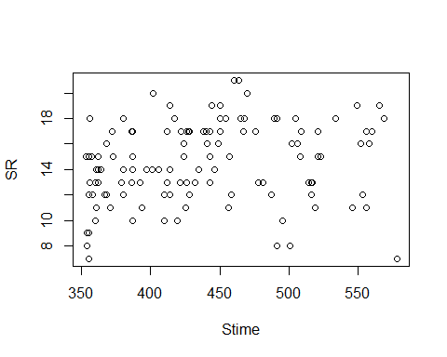

plot(evaluationYV9)

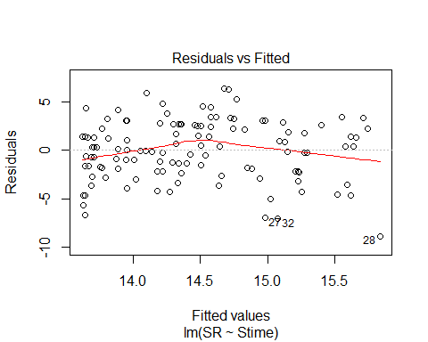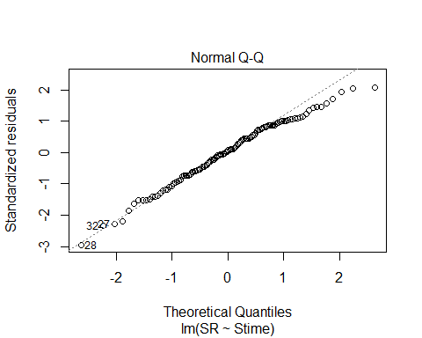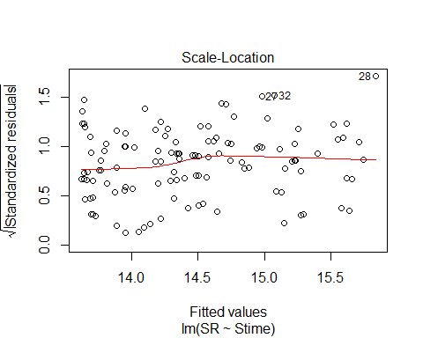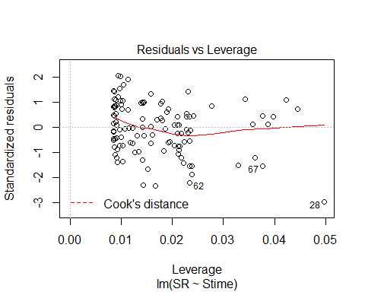

evaluationYV10<-lm(SR ~ Pdate, methodYSR2) #sig now!  
summary(evaluationYV10)

##   
## Call:  
## lm(formula = SR ~ Pdate, data = methodYSR2)  
##   
## Residuals:  
## Min 1Q Median 3Q Max   
## -8.2663 -2.3603 0.5613 2.6948 5.7022   
##   
## Coefficients:  
## Estimate Std. Error t value Pr(>|t|)   
## (Intercept) -6.673e+02 3.039e+02 -2.196 0.0322 *  
## Pdate 1.576e-02 7.023e-03 2.243 0.0288 *  
## ---  
## Signif. codes: 0 '***' 0.001 '**' 0.01 '*' 0.05 '.' 0.1 ' ' 1  
##   
## Residual standard error: 3.319 on 57 degrees of freedom  
## (59 observations deleted due to missingness)  
## Multiple R-squared: 0.08112, Adjusted R-squared: 0.065   
## F-statistic: 5.032 on 1 and 57 DF, p-value: 0.02878

confint(evaluationYV10, level=0.95)

## 2.5 % 97.5 %  
## (Intercept) -1.275876e+03 -58.81299735  
## Pdate 1.691069e-03 0.02981938

anova(evaluationYV10)

## Analysis of Variance Table  
##   
## Response: SR  
## Df Sum Sq Mean Sq F value Pr(>F)   
## Pdate 1 55.45 55.449 5.0321 0.02878 *  
## Residuals 57 628.08 11.019   
## ---  
## Signif. codes: 0 '***' 0.001 '**' 0.01 '*' 0.05 '.' 0.1 ' ' 1

plot(SR ~ Pdate, methodYSR2)

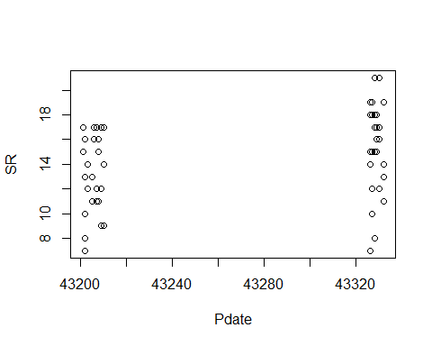

plot(evaluationYV10)

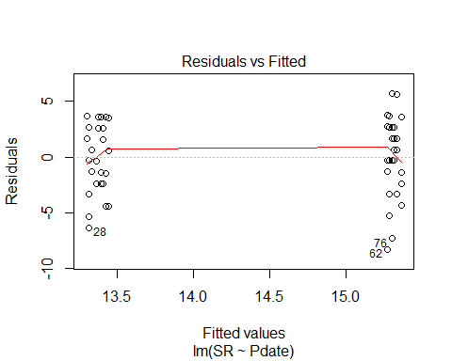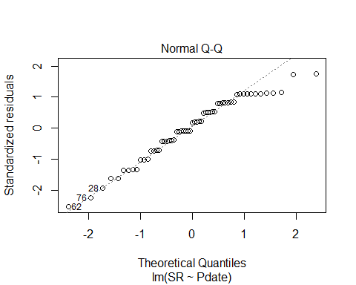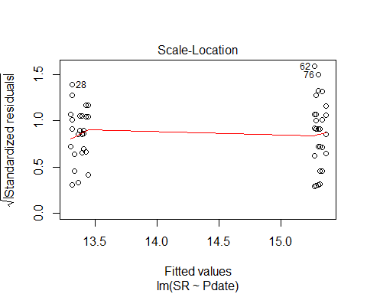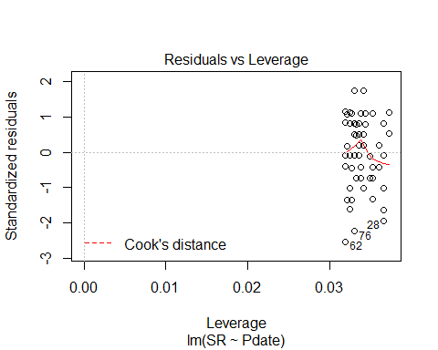

evaluationYV11<-lm(SR ~ Pmin, methodYSR2) #non-sig  
summary(evaluationYV11)

##   
## Call:  
## lm(formula = SR ~ Pmin, data = methodYSR2)  
##   
## Residuals:  
## Min 1Q Median 3Q Max   
## -7.4692 -2.4374 0.5308 2.5785 6.5308   
##   
## Coefficients:  
## Estimate Std. Error t value Pr(>|t|)   
## (Intercept) 14.88283 1.20915 12.309 <2e-16 ***  
## Pmin -0.03182 0.06778 -0.469 0.641   
## ---  
## Signif. codes: 0 '***' 0.001 '**' 0.01 '*' 0.05 '.' 0.1 ' ' 1  
##   
## Residual standard error: 3.456 on 57 degrees of freedom  
## (59 observations deleted due to missingness)  
## Multiple R-squared: 0.003852, Adjusted R-squared: -0.01362   
## F-statistic: 0.2204 on 1 and 57 DF, p-value: 0.6405

confint(evaluationYV11, level=0.95)

## 2.5 % 97.5 %  
## (Intercept) 12.4615468 17.3041084  
## Pmin -0.1675359 0.1038986

anova(evaluationYV11)

## Analysis of Variance Table  
##   
## Response: SR  
## Df Sum Sq Mean Sq F value Pr(>F)  
## Pmin 1 2.63 2.6329 0.2204 0.6405  
## Residuals 57 680.89 11.9455

evaluationYV12<-lm(SR ~ Peffort, methodYSR2) #non-sig  
summary(evaluationYV12)

##   
## Call:  
## lm(formula = SR ~ Peffort, data = methodYSR2)  
##   
## Residuals:  
## Min 1Q Median 3Q Max   
## -7.3739 -2.3594 0.6406 2.6406 6.6406   
##   
## Coefficients:  
## Estimate Std. Error t value Pr(>|t|)   
## (Intercept) 14.38839 0.80149 17.952 <2e-16 ***  
## Peffort -0.01451 0.29620 -0.049 0.961   
## ---  
## Signif. codes: 0 '***' 0.001 '**' 0.01 '*' 0.05 '.' 0.1 ' ' 1  
##   
## Residual standard error: 3.463 on 57 degrees of freedom  
## (59 observations deleted due to missingness)  
## Multiple R-squared: 4.209e-05, Adjusted R-squared: -0.0175   
## F-statistic: 0.002399 on 1 and 57 DF, p-value: 0.9611

confint(evaluationYV12, level=0.95)

## 2.5 % 97.5 %  
## (Intercept) 12.7834395 15.9933462  
## Peffort -0.6076344 0.5786165

anova(evaluationYV12)

## Analysis of Variance Table  
##   
## Response: SR  
## Df Sum Sq Mean Sq F value Pr(>F)  
## Peffort 1 0.03 0.0288 0.0024 0.9611  
## Residuals 57 683.50 11.9912

# Visit 3 - all variables

#File read-in  
methodYSR3 <-read.csv("17_18_3by3_ACPC_SR.csv") #SR by count #3 each - Site Type SR  
#summary(methodYSR3)  
str(methodYSR3)

## 'data.frame': 118 obs. of 9 variables:  
## $ SiteName: Factor w/ 37 levels "Abercrombie_0B_E_AB",..: 4 5 6 8 9 15 16 17 18 19 ...  
## $ Type : Factor w/ 2 levels "AC","PC": 1 1 1 1 1 1 1 1 1 1 ...  
## $ SR : int 10 16 11 16 16 16 14 14 15 14 ...  
## $ Sdate : int 15 18 47 33 22 33 34 29 10 20 ...  
## $ Stime : int 363 500 380 513 559 507 526 359 395 566 ...  
## $ Pdate : int 43214 43214 43216 43219 43220 43215 43216 43216 43217 43216 ...  
## $ Pmin : int 18 15 14 27 12 26 14 19 24 19 ...  
## $ Peffort : int 1 2 2 7 2 8 2 4 5 5 ...  
## $ Year : Factor w/ 2 levels "A","B": 1 1 1 1 1 1 1 1 1 1 ...

plot(methodYSR3$SR ~ methodYSR3$Type) #



#plot(SR ~ Type, data=methodSR) #same as above

evaluationYV13<-lm(SR ~ Type, methodYSR3) #YES, now sig! on border of 0.05  
summary(evaluationYV13)

##   
## Call:  
## lm(formula = SR ~ Type, data = methodYSR3)  
##   
## Residuals:  
## Min 1Q Median 3Q Max   
## -7.2712 -1.2712 -0.2203 1.7288 6.7288   
##   
## Coefficients:  
## Estimate Std. Error t value Pr(>|t|)   
## (Intercept) 14.2712 0.3440 41.488 <2e-16 ***  
## TypePC 0.9492 0.4865 1.951 0.0535 .   
## ---  
## Signif. codes: 0 '***' 0.001 '**' 0.01 '*' 0.05 '.' 0.1 ' ' 1  
##   
## Residual standard error: 2.642 on 116 degrees of freedom  
## Multiple R-squared: 0.03178, Adjusted R-squared: 0.02343   
## F-statistic: 3.807 on 1 and 116 DF, p-value: 0.05345

confint(evaluationYV13, level=0.95)

## 2.5 % 97.5 %  
## (Intercept) 13.58989105 14.95248  
## TypePC -0.01434464 1.91265

anova(evaluationYV13)

## Analysis of Variance Table  
##   
## Response: SR  
## Df Sum Sq Mean Sq F value Pr(>F)   
## Type 1 26.58 26.576 3.8069 0.05345 .  
## Residuals 116 809.80 6.981   
## ---  
## Signif. codes: 0 '***' 0.001 '**' 0.01 '*' 0.05 '.' 0.1 ' ' 1

plot(SR ~ Type, methodYSR3)

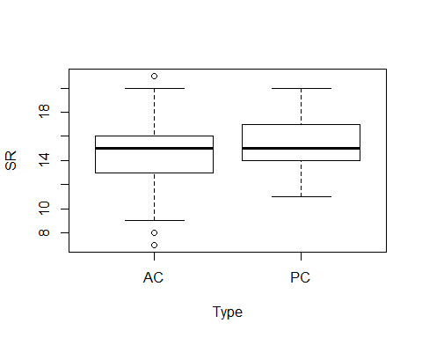

plot(evaluationYV13)

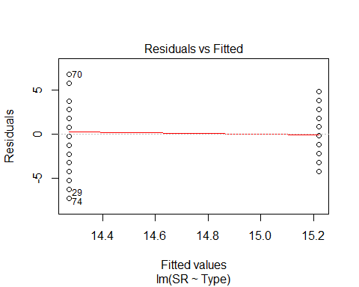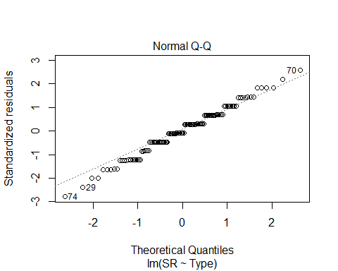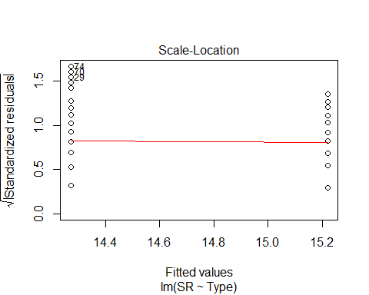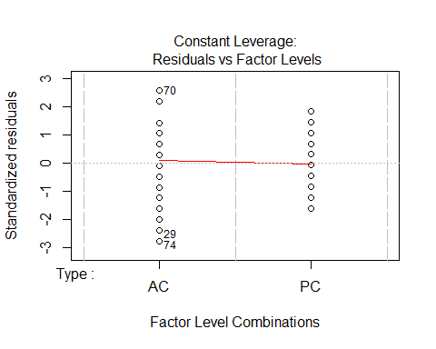

evaluationYV14<-lm(SR ~ Sdate, methodYSR3) #non-sig  
summary(evaluationYV14)

##   
## Call:  
## lm(formula = SR ~ Sdate, data = methodYSR3)  
##   
## Residuals:  
## Min 1Q Median 3Q Max   
## -7.7697 -1.7410 0.2472 1.2607 6.2472   
##   
## Coefficients:  
## Estimate Std. Error t value Pr(>|t|)   
## (Intercept) 14.801863 0.336647 43.969 <2e-16 ***  
## Sdate -0.001691 0.006890 -0.245 0.807   
## ---  
## Signif. codes: 0 '***' 0.001 '**' 0.01 '*' 0.05 '.' 0.1 ' ' 1  
##   
## Residual standard error: 2.684 on 116 degrees of freedom  
## Multiple R-squared: 0.0005189, Adjusted R-squared: -0.008097   
## F-statistic: 0.06022 on 1 and 116 DF, p-value: 0.8066

confint(evaluationYV14, level=0.95)

## 2.5 % 97.5 %  
## (Intercept) 14.13509176 15.46863368  
## Sdate -0.01533789 0.01195612

anova(evaluationYV14)

## Analysis of Variance Table  
##   
## Response: SR  
## Df Sum Sq Mean Sq F value Pr(>F)  
## Sdate 1 0.43 0.4340 0.0602 0.8066  
## Residuals 116 835.94 7.2064

evaluationYV15<-lm(SR ~ Stime, methodYSR3) #sig  
summary(evaluationYV15)

##   
## Call:  
## lm(formula = SR ~ Stime, data = methodYSR3)  
##   
## Residuals:  
## Min 1Q Median 3Q Max   
## -6.6887 -1.5155 0.1473 1.4759 5.9203   
##   
## Coefficients:  
## Estimate Std. Error t value Pr(>|t|)   
## (Intercept) 8.344255 1.593613 5.236 7.40e-07 ***  
## Stime 0.014642 0.003606 4.060 8.95e-05 ***  
## ---  
## Signif. codes: 0 '***' 0.001 '**' 0.01 '*' 0.05 '.' 0.1 ' ' 1  
##   
## Residual standard error: 2.513 on 116 degrees of freedom  
## Multiple R-squared: 0.1244, Adjusted R-squared: 0.1169   
## F-statistic: 16.48 on 1 and 116 DF, p-value: 8.946e-05

confint(evaluationYV15, level=0.95)

## 2.5 % 97.5 %  
## (Intercept) 5.187903242 11.50060647  
## Stime 0.007499126 0.02178533

anova(evaluationYV15)

## Analysis of Variance Table  
##   
## Response: SR  
## Df Sum Sq Mean Sq F value Pr(>F)   
## Stime 1 104.06 104.060 16.483 8.946e-05 ***  
## Residuals 116 732.31 6.313   
## ---  
## Signif. codes: 0 '***' 0.001 '**' 0.01 '*' 0.05 '.' 0.1 ' ' 1

plot(SR ~ Stime, methodYSR3)

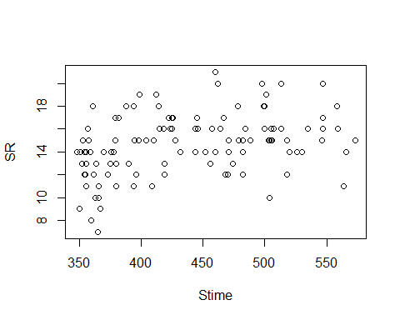

plot(evaluationYV15)

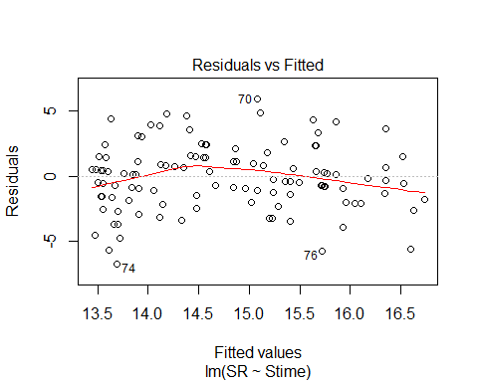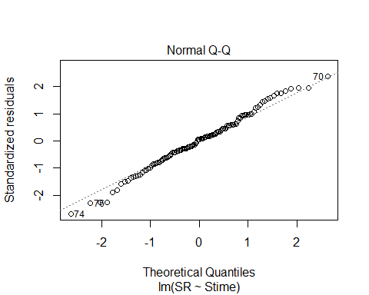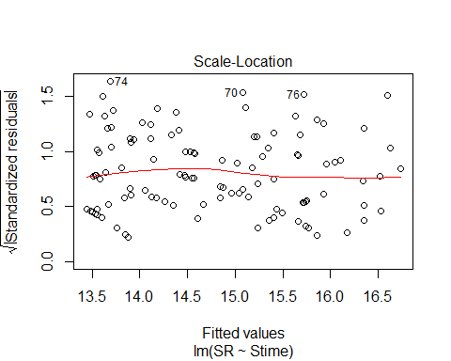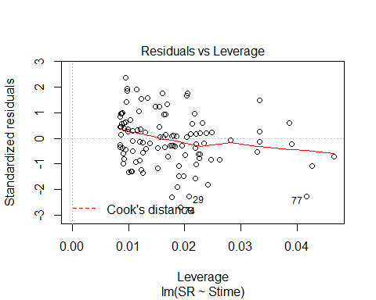

evaluationYV16<-lm(SR ~ Pdate, methodYSR3) #non-sig  
summary(evaluationYV16)

##   
## Call:  
## lm(formula = SR ~ Pdate, data = methodYSR3)  
##   
## Residuals:  
## Min 1Q Median 3Q Max   
## -7.0953 -1.4595 0.5421 1.5467 6.9109   
##   
## Coefficients:  
## Estimate Std. Error t value Pr(>|t|)  
## (Intercept) 148.406076 270.348404 0.549 0.585  
## Pdate -0.003099 0.006247 -0.496 0.622  
##   
## Residual standard error: 2.852 on 57 degrees of freedom  
## (59 observations deleted due to missingness)  
## Multiple R-squared: 0.0043, Adjusted R-squared: -0.01317   
## F-statistic: 0.2462 on 1 and 57 DF, p-value: 0.6217

confint(evaluationYV16, level=0.95)

## 2.5 % 97.5 %  
## (Intercept) -392.95726437 6.897694e+02  
## Pdate -0.01560861 9.409745e-03

anova(evaluationYV16)

## Analysis of Variance Table  
##   
## Response: SR  
## Df Sum Sq Mean Sq F value Pr(>F)  
## Pdate 1 2.00 2.0024 0.2462 0.6217  
## Residuals 57 463.66 8.1344

evaluationYV17<-lm(SR ~ Pmin, methodYSR3) #non-sig  
summary(evaluationYV17)

##   
## Call:  
## lm(formula = SR ~ Pmin, data = methodYSR3)  
##   
## Residuals:  
## Min 1Q Median 3Q Max   
## -7.1262 -1.3553 0.3391 1.7210 6.8738   
##   
## Coefficients:  
## Estimate Std. Error t value Pr(>|t|)   
## (Intercept) 13.20962 1.37821 9.585 1.74e-13 ***  
## Pmin 0.07638 0.09552 0.800 0.427   
## ---  
## Signif. codes: 0 '***' 0.001 '**' 0.01 '*' 0.05 '.' 0.1 ' ' 1  
##   
## Residual standard error: 2.842 on 57 degrees of freedom  
## (59 observations deleted due to missingness)  
## Multiple R-squared: 0.01109, Adjusted R-squared: -0.006257   
## F-statistic: 0.6394 on 1 and 57 DF, p-value: 0.4273

confint(evaluationYV17, level=0.95)

## 2.5 % 97.5 %  
## (Intercept) 10.4497921 15.9694430  
## Pmin -0.1149004 0.2676627

anova(evaluationYV17)

## Analysis of Variance Table  
##   
## Response: SR  
## Df Sum Sq Mean Sq F value Pr(>F)  
## Pmin 1 5.17 5.1654 0.6394 0.4273  
## Residuals 57 460.50 8.0789

evaluationYV18<-lm(SR ~ Peffort, methodYSR3) #non-sig  
summary(evaluationYV18)

##   
## Call:  
## lm(formula = SR ~ Peffort, data = methodYSR3)  
##   
## Residuals:  
## Min 1Q Median 3Q Max   
## -6.8374 -1.2783 0.1626 1.7862 6.7862   
##   
## Coefficients:  
## Estimate Std. Error t value Pr(>|t|)   
## (Intercept) 13.4611 0.6141 21.919 <2e-16 ***  
## Peffort 0.3763 0.2299 1.637 0.107   
## ---  
## Signif. codes: 0 '***' 0.001 '**' 0.01 '*' 0.05 '.' 0.1 ' ' 1  
##   
## Residual standard error: 2.793 on 57 degrees of freedom  
## (59 observations deleted due to missingness)  
## Multiple R-squared: 0.0449, Adjusted R-squared: 0.02815   
## F-statistic: 2.68 on 1 and 57 DF, p-value: 0.1071

confint(evaluationYV18, level=0.95)

## 2.5 % 97.5 %  
## (Intercept) 12.23132535 14.6908331  
## Peffort -0.08401689 0.8367149

anova(evaluationYV18)

## Analysis of Variance Table  
##   
## Response: SR  
## Df Sum Sq Mean Sq F value Pr(>F)  
## Peffort 1 20.91 20.9097 2.6798 0.1071  
## Residuals 57 444.75 7.8027